

## SESTICKET – PROJECT INFORMATION AND USER MANUAL

**SUMMARY**

1. DOCUMENT HISTORY 3

2. ABOUT THE DOCUMENT 4

3. PROJECT 4

3.1. ABOUT THE SYSTEM 4

3.2. OBJECTIVES AND GOALS 4

3.3. SPONSORS 4

4. IT 5

4.1. SYSTEM ARCHITECTURE 5

4.2. SERVER 5

4.3. DATABASE CONNECTION 5

4.4. SESTICKET - DIRECTORY STRUCTURE ON CLIENT 6

4.5. SESTICKET - DIRECTORY STRUCTURE ON APPLICATION SERVER 6

4.6. CLIENT INSTALLATION 6

5. SESTICKET 7

5.1. HOW THE APPLICATION WORKS? SYNCHRONIZATION! 7

5.2. LOGIN – STARTING THE APPLICATION 10

5.3. MAIN SCREEN 12

5.4. BASE DATA 13

5.4.1. USER 15

5.4.1. EQUIPMENT 17

5.4.1. WORKER 18

5.4.1. INVENTORY UNIT 20

5.4.1. INVENTORY CLASS 21

5.4.1. INVENTORY ITEM 22

5.4.1. CUSTOMER 24

5.4.1. CONTRACT 25

5.4.1. CONTRACT PRICE 28

5.4.1. SITES 30

5.4.1. PETROLEUM FIELDS 32

5.4.1. WELL 33

5.4.1. SERVICE TYPE 34

5.4.1. EXPORT UTILITY 35

5.4.1. IMPORT UTILITY 37

5.5. TICKET 41

5.5.1. UNDERSTAND THE TICKET 41

5.5.1. CREATE A NEW TICKET 42

5.5.1. ADDICTIONAL INFORMATION 44

5.5.1. SALES ITEM 45

5.5.2. INVENTORY ITEM 51

5.5.3. EQUIPMENT 54

5.5.4. WORKERS 55

5.5.5. JOB LOG 57

5.5.6. REPORTS 60

5.5.7. CLOSE TICKET 63

5.5.8. CLONE TICKET 63

5.5.9. ATTACHMENT 65

5.5.10. MANAGE TICKET FROM DB 68

5.1. REPORTS (MANAGER REPORTS) 71

# DOCUMENT HISTORY

|  |  |  |  |
| --- | --- | --- | --- |
| **VERSION** | **DESCRIPTION** | **AUTHOR** | **UPDATE DATE** |
| 1.0 | Document Creation | Fernando Melo | 19/JUL/2017 |
|  |  |  |  |
|  |  |  |  |
|  |  |  |  |
|  |  |  |  |
|  |  |  |  |
|  |  |  |  |

# ABOUT THE DOCUMENT

This document contains all information about SESTicket system.

# PROJECT

## ABOUT THE SYSTEM

The SESTicket is a system developed by Superior IT LATAM. The main objective is provide a better administration about the Service Tickets made by Colombia´s Engineers.

The Idea to create a new system to control the tickets emerged after problems with “SmartTickets” system. His provider is not update the new versions and the features is not covering the Superior´s necessities.

## OBJECTIVES AND GOALS

* Manage the contracts, prices and inventory in a unique repository;
* The application should be able to work offline to generate a service tickets, provide invoices and reports. This is an important objective because the users couldn’t have a connection with Superior network.
* Synchronize all BaseData, Service Ticket and Attachments created by uses;
* The application should be authenticate through Active Directory (AD) and if the user is not connected in Superior network an offline authenticate mode should be made.

## SPONSORS

The sponsors of this project are:

* Alejandro Casas – IT Manager LATAM
* Liliana Barrios – Account Payable Manager Colombia (Key User)
* Mauricio Balsero – Country Manager Colombia

# IT

## SYSTEM ARCHITECTURE

|  |  |
| --- | --- |
| Application Architecture: | Client/Server |
| Developed in: | Microsoft Visual Basic .Net 2013 - Windows Forms. |
| Database: | Version: SQL Server 2014 SP2 (with compatibility mode 2008 R2)  Collation: Latin1_General_CI_AS  Microsoft Access 2010 |

## SERVER

|  |  |
| --- | --- |
| Application Server: | colapp07 (used by storage the system files) |
| Database Server: | colsql01 |
| Database: | SESTICKET |
| Username: | usrSESTICKET |
| Active Directory: | MBAPAD01 |

## DATABASE CONNECTION

**2**

**3**

**1**







1 – The application stablish a connection with MS Access Databases: SESTicket.accdb and SESTicketBaseData.accdb

2 – The application checks if have a connection with Superior network. If yes, a connection between MS Access database (through Linked Table feature) and SQL Server is stablished

3 – The application checks if have a connection with Superior network. If yes, a connection between application and SQL Server is stablished directly

The username “usrSESTICKET” is used in all connection process.

If necessary change the password of this user the developer should be change configuration file **SESTicket.exe.config** located in C:\SESTicket\app and connect **each MS Access** and change the linked table connection.

## SESTICKET - DIRECTORY STRUCTURE ON CLIENT

Following the directory structure used in SESTicket:

|  |  |
| --- | --- |
| C:\SESTicket | - Main directory |
| \app | - Binaries directory |
| \appupd | - Update utility directory (created automatically by application) |
| \data | - Database MS Access directory |
| \file | - Other files directory (attachments, temporary, backups, etc.) – Automatically by application |

## SESTICKET - DIRECTORY STRUCTURE ON APPLICATION SERVER

Following the directory structure used in SESTicket:

|  |  |
| --- | --- |
| C:\apps\SESTicket | - Main directory |
| \Docs | - System Documentation |
| \File | - Directory used in the Attachment Synchronization |
| \Release | - Release version and components to installation on client |
| \SESTicketUpd | - SESTicket Update Tool |
| \Source | - SESTicket Source (current version) |

## CLIENT INSTALLATION

The installation client details are in the document called “SESTicket - Installation Client Guide .docx”

# SESTICKET

## HOW THE APPLICATION WORKS? SYNCHRONIZATION!

The SESTicket system was designed to work online and offline. When the user works offline all information are storage locally and, when connected on Superior network (SES Net), copy to the database and application server thought process called “Synchronization process”.

SESTicket has a structure with 3 kind of synchronization process. The process is enable when the computer has connection with Superior network. The objective of these process is keeping up-to-date all basedata, ticket and attachment information.

**BASEDATA**: The BaseData sync process consists in keep up-to-date the information about:

CONTRACT, CONTRACTPRICELIST, CUSTOMER, EQUIPMENT, INVENTORY (CLASS, ITEM, UNIT), PETROLEUM FIELDS, SERVICE TYPE, SITE, CASING, TUBBING, WELL, WORKER and USER.

If user change any information in BaseData tables the system keep in track each information. When the user connects on the Superior network the system checks if all tables is up-to-date. If not synchronized, the system should be synchronize the BaseData.

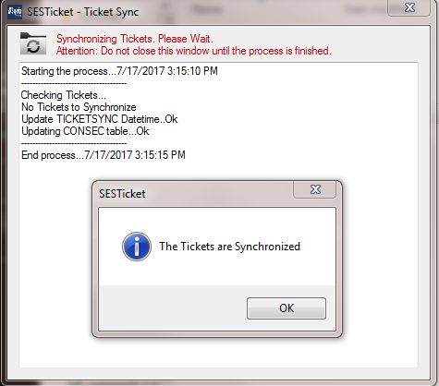

The user can call the sync Base Data process by demand through “Update BaseData” menu in Main Screen (in yellow).

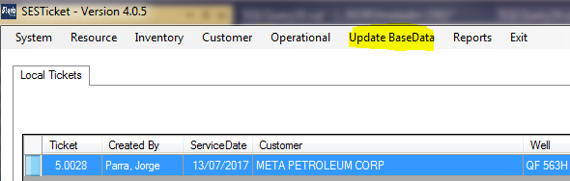

**TICKET**: The Ticket sync process consists in keep up-to-date the information about the Service Ticket:

TICKET, TICKET WORKER, TICKET EQUIPMENT, TICKET SALES ITEM, TICKET INVENTORY and OPERATION REPORT

If user change any information in Service Ticket tables the system keep in track each information. When the user connects on the Superior network the system checks if all tables is up-to-date. If not synchronized, the system should be synchronize the Ticket.

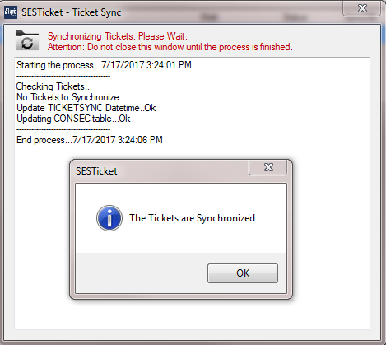

The user can call the sync Ticket process by demand through “Synchronize Ticket” button in Main Screen (in yellow).

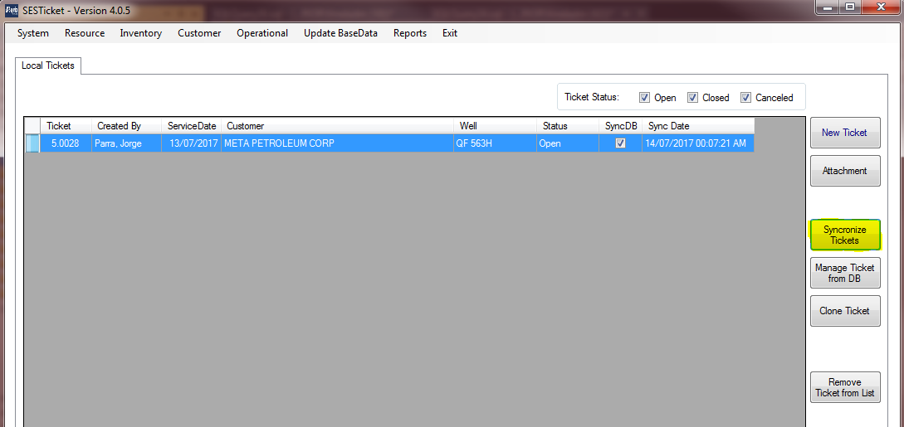

**ATTACHMENTS**: The Attachment sync process consists in keep up-to-date the files attached by users in the Application Server.

The sync process is different of others: The system checks if the connect with Superior network was established. If yes, the background process called “SESTicketSyncAttach.exe” is started and all synchronization is started until the end of the application.

## LOGIN – STARTING THE APPLICATION

The process of Login in the system consist in following Flowchart:

No

No

User Starts the Application

Is connected on SES Network?

Synchronize USER data

USER input credentials

Is Active Directory valid user?

Sync BaseData, Ticket and Attachment are started

Show Main Screen

The valid password is keeping on the local table

USER input credentials

Is Local Table valid user?

No

Yes

Yes

Yes

Steps to user connects on the application:

A – Start the application through shortcut called “SESTicket.exe”

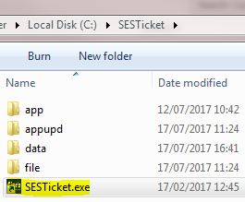

B – At this moment the system is checking if the computer is connected on the Superior Network.

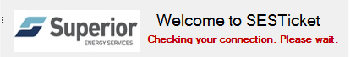

If not connected, the screen below is showing advice about it.

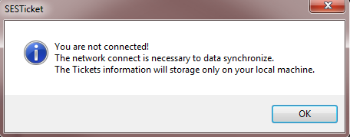

C – Inform the Username and Password.

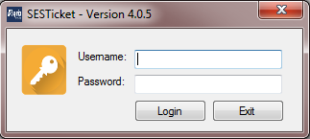

D – If computer is connected on Superior Network, the synchronization process is started (see details on chapter 5.1). If not, the main screen will be exhibit.

## MAIN SCREEN

After login, the Main Screen is exhibit. Depends on of the User Right (we will see about it on Base Data screens) or if the computer is online, some options could be or could not be available.

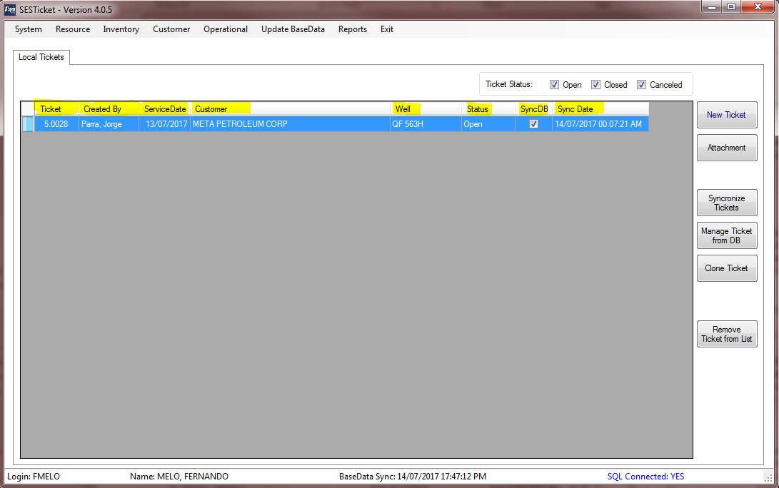

The Main Screen shows the tickets are available locally with this information:

* Ticket – It’s a Service Ticket ID,
* Created by – How creates the Service Ticket
* Service Date
* Customer
* Well
* Status – It´s a Ticket Status (open, close, cancelled)
* SyncDB – If the ticket is synchronize with Database (checked) or not (not checked)
* Sync Date – It’s for internal control purpose.

## BASE DATA

The Base Data are auxiliary information used on the system and/or in tickets. This chapter will talk about more each Base Data screen. The information exhibits on the screen are storage on Database server. That is an important information.

The Base Data screen has by default the following screen layout:

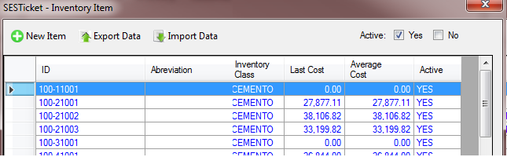

* The grid exhibits a resume of all information of Base Data. (example: the grid is showing information Inventory Item)
* All screens has the button “New Item” to include a new information;
* Active Yes and No: The system not Delete a row. Instead the row is Active (available to use) or not Active (not available to use).
* To edit the registry just make a double click on the line (example below):

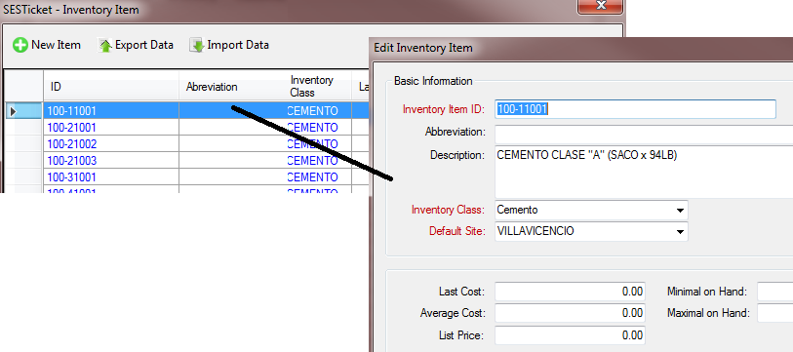

* After any update/new registry the system will ask if you want synchronize the Base Data information;

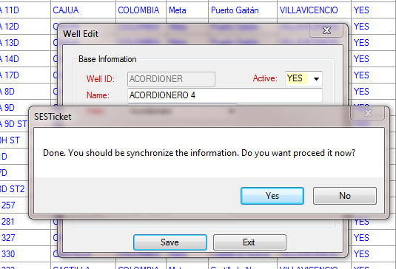

* Import and Export Data menu: Lets be check after.

### USER

The Base Data “USER” has information about the system user. To get information this Base Data you should access are auxiliary information used on the system and/or in tickets. This chapter will talk about more each Base Data screen.

To access the Base Data “USER” open the menu “System” – “Users”.

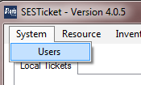

The screen will be shown with the all USER data available.

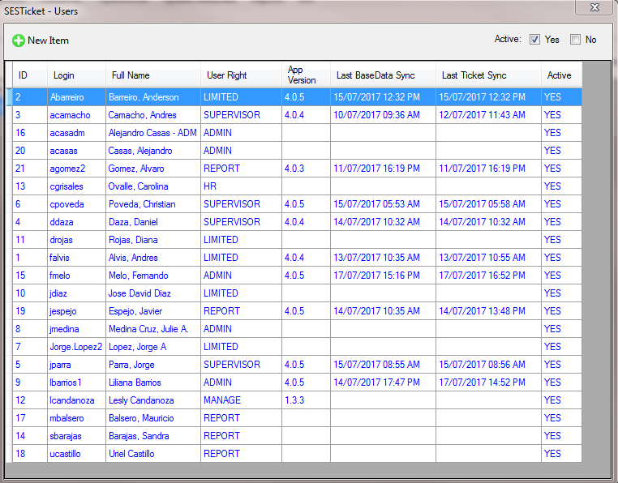

We talked about the information about USER basedata, but these columns below are not available to edit (it’s for internal control):

* AppVersion – Show the App Version used by users on last synchronization process
* Last BaseData Sync – Show the date time of last BaseData synchronization process made by user.
* Last Ticket Sync – Show the date time of last Ticket synchronization process made by user.

Information about USER Base Data. The field in red are obligatory.

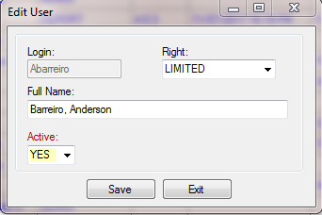

* Login: It’s a User Login (Its must the same of Active Directory)
* Full Name: Full user name
* Active: Yes (active) No (not active)
* Right: This is a user rights on the system. Following the details for each option:

|  |  |
| --- | --- |
| **Right** | **Details** |
| ADMIN | The system administrator role (full access). |
| LIMITED | The user can create only his tickets;  No access on Base Data menu or Reports menu on Main Screen |
| SUPERVISOR | The same of LIMITED right plus access BaseData “Well” |
| REPORT | The user has grant access on menu “Reports” on Main Screen |
| HR | The user has grant access on BaseData “WORKER” and Reports menu on Main Screen |
| MANAGE | The user has grant on all BaseData screen except BaseData “Worker” |

### EQUIPMENT

The Base Data “EQUIPMENT” has information about the equipment that could be or not used on the service Ticket.

To access the Base Data “EQUIPMENT” open the menu “Resource” – “Equipment”.

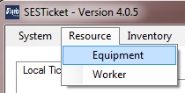

The screen will be shown with the all EQUIPMENT data available.

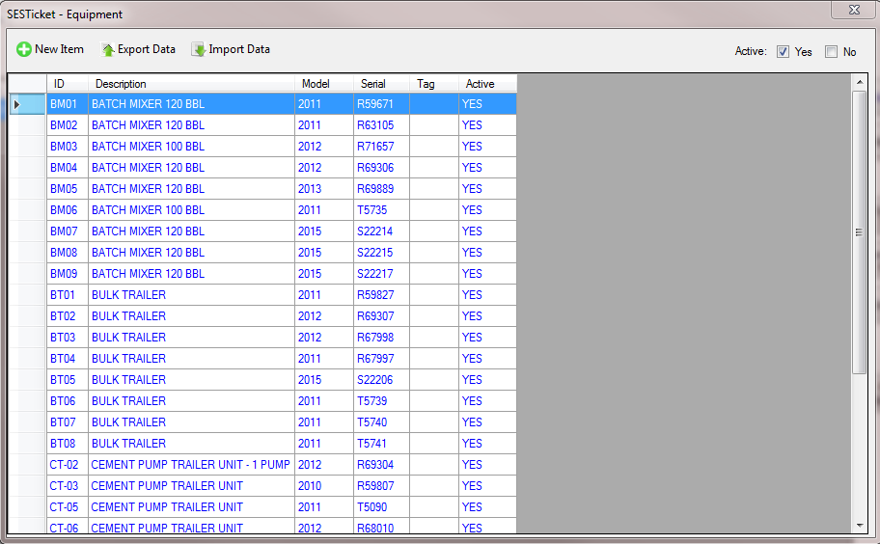

Information about EQUIPMENT Base Data. The field in red are obligatory.

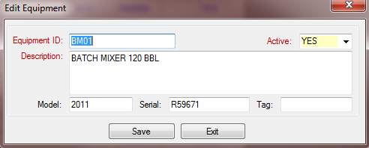

|  |  |  |
| --- | --- | --- |
| **Field** | **Type** | **Description** |
| Equipment ID | Text | Equipment Identification |
| Active | Boolean | Yes (active) No (not active) |
| Description | Text | Equipment Description |
| Model | Text | Equipment Model |
| Serial | Text | Equipment Serial |
| Tag | Text | Equipment Tag |

### WORKER

The Base Data “WORKER” has information about the worker that available to participate of customer service ticket.

To access the Base Data “WORKER” open the menu “Resource” – “Worker”.

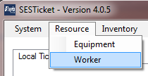

The screen will be shown with the all WORKER data available.

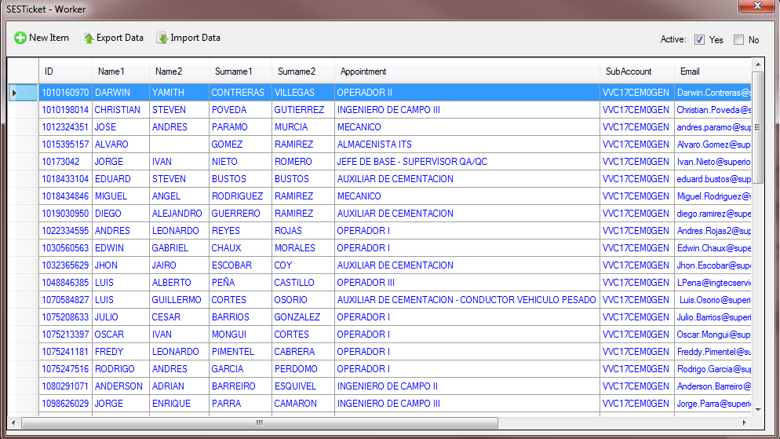

Information about WORKER Base Data. The field in red are obligatory.

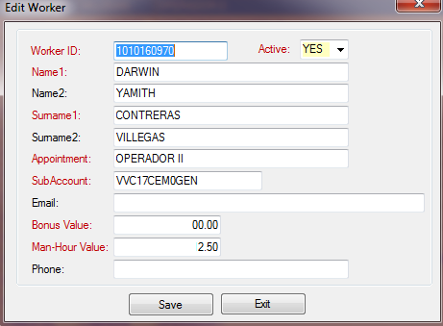

|  |  |  |
| --- | --- | --- |
| **Field** | **Type** | **Description** |
| Worker ID | Text | Worker Identification |
| Active | Boolean | Yes (active) No (not active) |
| Name1 | Text | Worker Name1 |
| Name2 | Text | Worker Name2 |
| Surname1 | Text | Worker Surname1 |
| Surname2 | Text | Worker Surname2 |
| Appointment | Text | Worker position on the Superior |
| SubAccount | Text | Subaccount – field imported from SmartTickets |
| Email | Text | Worker email |
| Bonus Value | Number | Bonus Value of the Worker |
| Man-Hour Value | Number | Man-Hour Value of the Worker |
| Phone | Text | Worker Phone number |

### INVENTORY UNIT

The Base Data “INVENTORY UNIT” has information about the units used on Inventory Item.

To access the Base Data “INVENTORY UNIT” open the menu “Inventory” – “Unit”.

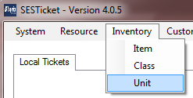

The screen will be shown with the all INVENTORY UNIT data available.

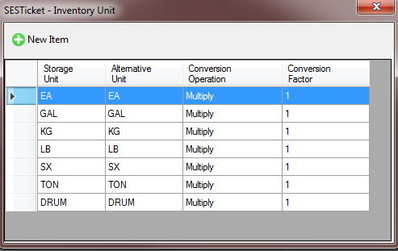

Information about INVENTORY UNIT Base Data. The field in red are obligatory.

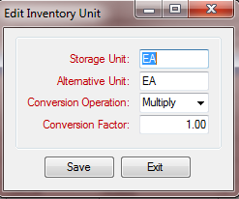

|  |  |  |
| --- | --- | --- |
| **Field** | **Type** | **Description** |
| Storage Unit | Text | Storage Unit |
| Alternative Unit | Text | Alternative Unit |
| Conversion Operation | Text | Conversion Operation |
| Conversion Factor | Numeric | Conversion Factor |

### INVENTORY CLASS

The Base Data “INVENTORY CLASS” has information about the Classes used on Inventory Item and Contracts.

To access the Base Data “INVENTORY CLASS” open the menu “Inventory” – “Class”.

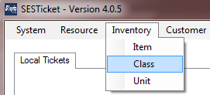

The screen will be shown with the all INVENTORY CLASS data available.

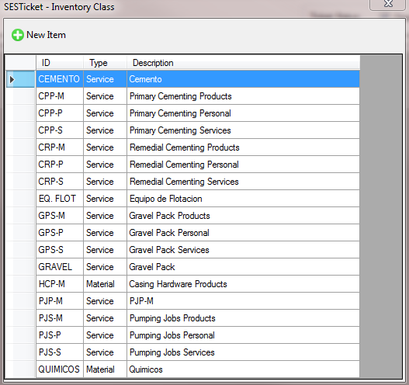

Information about INVENTORY CLASS Base Data. The field in red are obligatory.

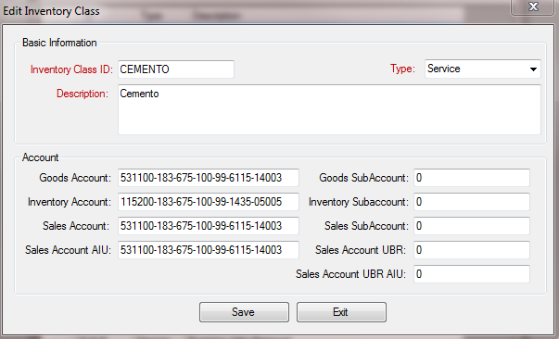

|  |  |  |
| --- | --- | --- |
| **Field** | **Type** | **Description** |
| Inventory Class ID | Text | Inventory Class Identification |
| Type | Text | Inventory Class Type (“Material” or “Service”) |
| Description | Text | Description of Inventory Class |
| Goods Account | Text | Created from SmartTickets |
| Goods SubAccount | Text | Created from SmartTickets |
| Inventory Account | Text | Created from SmartTickets |
| Inventory SubAccount | Text | Created from SmartTickets |
| Sales Account | Text | Created from SmartTickets |
| Sales SubAccount | Text | Created from SmartTickets |
| Sales Account AIU | Text | Created from SmartTickets |
| Sales Account UBR | Text | Created from SmartTickets |
| Sales Account UBR AIU | Text | Created from SmartTickets |

### INVENTORY ITEM

The Base Data “INVENTORY ITEM” has information about the Inventory Item used on the Tickets Sales Item.

To access the Base Data “INVENTORY ITEM” open the menu “Inventory” – “Item”.

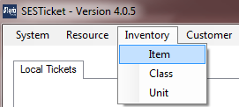

The screen will be shown with the all INVENTORY ITEM data available.

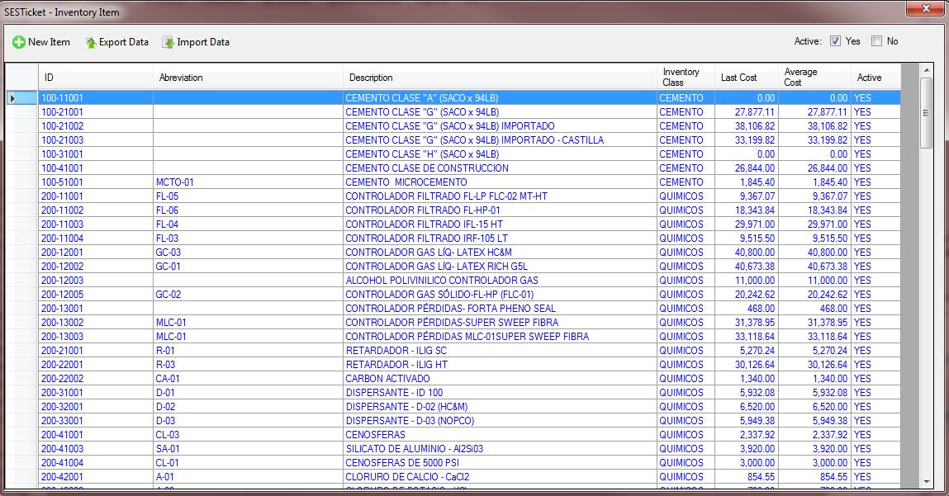

Information about INVENTORY CLASS Base Data. The field in red are obligatory.

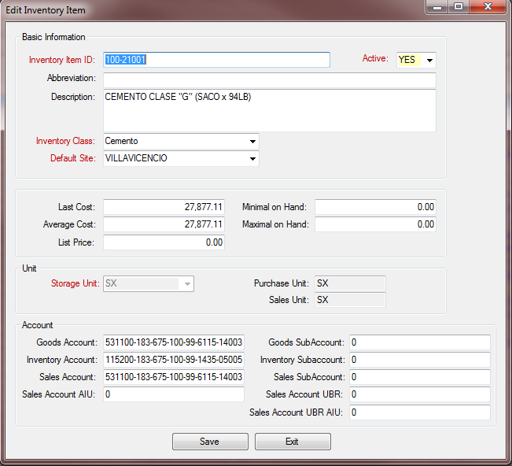

|  |  |  |
| --- | --- | --- |
| **Field** | **Type** | **Description** |
| Inventory Item ID | Text | Inventory Item Identification |
| Active | Boolean | Yes (active) No (not active) |
| Abbreviation | Text | Item Abbreviation to easy the search and organization |
| Description | Text | Item full description |
| Inventory Class | Text | Item Inventory Class (provided from INVENTORY CLASS BaseData) |
| Default Site | Text | Default site of the Item (provided from SITE BaseData) |
| Last Cost | Number | Item Last Cost |
| Average Cost | Number | Item Average Cost |
| List Price | Number | Item List Price |
| Minimal on Hand | Number | Created from SmartTickets |
| Maximal on Hand | Number | Created from SmartTickets |
| Storage Unit | Text | Item Unit (provided from INVENTORY UNIT BaseData) |
| Goods Account | Text | Created from SmartTickets |
| Goods SubAccount | Text | Created from SmartTickets |
| Inventory Account | Text | Created from SmartTickets |
| Inventory SubAccount | Text | Created from SmartTickets |
| Sales Account | Text | Created from SmartTickets |
| Sales SubAccount | Text | Created from SmartTickets |
| Sales Account AIU | Text | Created from SmartTickets |
| Sales Account UBR | Text | Created from SmartTickets |
| Sales Account UBR AIU | Text | Created from SmartTickets |

### CUSTOMER

The Base Data “CUSTOMER” has information about the Customers.

To access the Base Data “CUSTOMER” open the menu “Customer” – “Customer”.

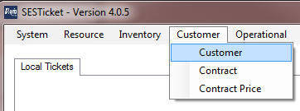

The screen will be shown with the all CUSTOMER data available.

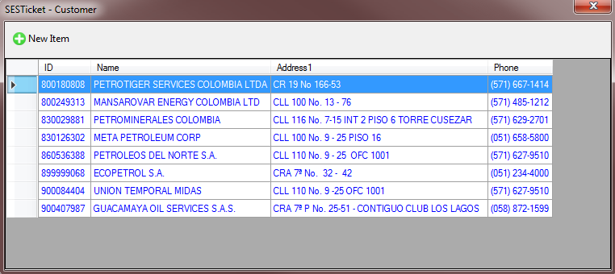

Information about CUSTOMER Base Data. The field in red are obligatory.

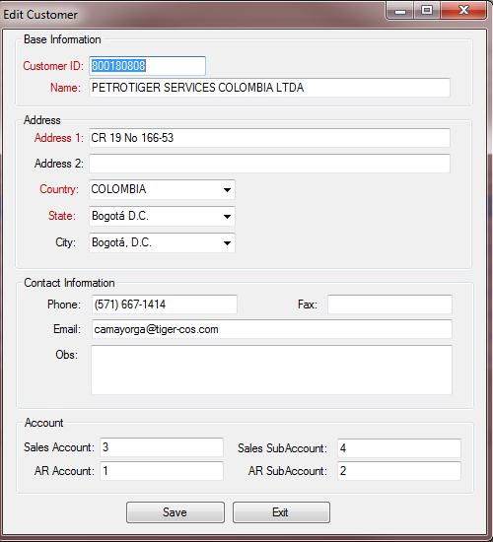

|  |  |  |
| --- | --- | --- |
| **Field** | **Type** | **Description** |
| Customer ID | Text | Customer Identification |
| Name | Text | Customer Name |
| Address1 | Text | Customer Address1 (main address) |
| Address2 | Text | Customer Address2 |
| Country | Text | Country |
| State | Text | State |
| City | Text | City |
| Phone | Text | Phone number |
| Fax | Text | Fax number |
| Email | Text | Main email contact |
| Obs | Text | Observation (for internal control) |
| Sales Account | Text | Created from SmartTickets |
| Sales SubAccount | Text | Created from SmartTickets |
| AR Account | Text | Created from SmartTickets |
| AR SubAccount | Text | Created from SmartTickets |

### CONTRACT

The Base Data “CONTRACT” has information about the Customer´s Contract. This contract are a core information in all system.

To access the Base Data “CONTRACT” open the menu “Customer” – “Contract”.

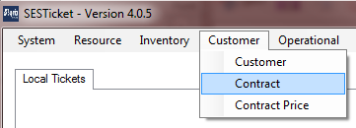

The screen will be shown with the all CONTRACT data available.

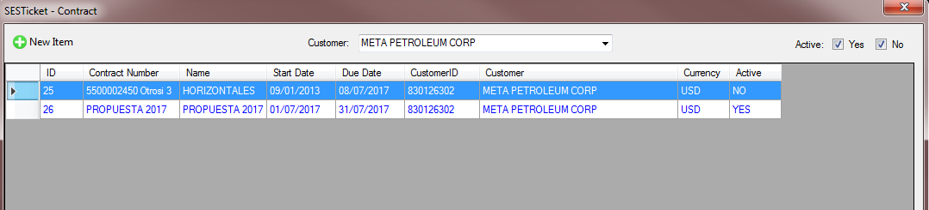

The contract is divide in 2 layout of types. This layouts are used in the Ticket Sales Item calculations and generate the specific reports. The calculated field changed depends on the layout.

Following the details of each one:

**Layout: L01-Meta Petroleum**

* The tickets does not permits give Discounts on the Sales Items.
* Ticket Sales Item will calculate the Portions.

Example of Sales Item screen:

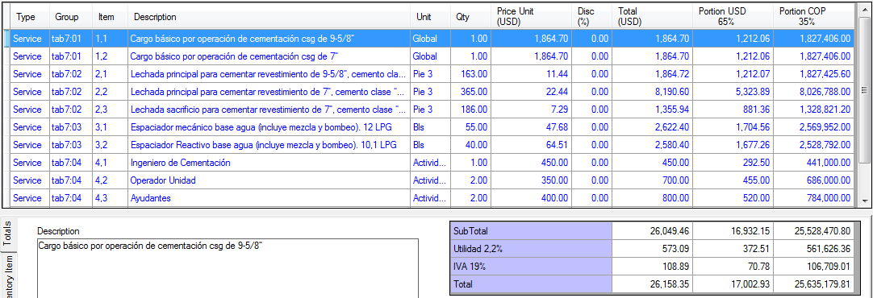

**Layout: L02-Ecopetrol**

* The tickets are available to generate Discounts
* The Material and Services taxes and totals are generated independents of each other.
* This layout does not use the Portion

Example:

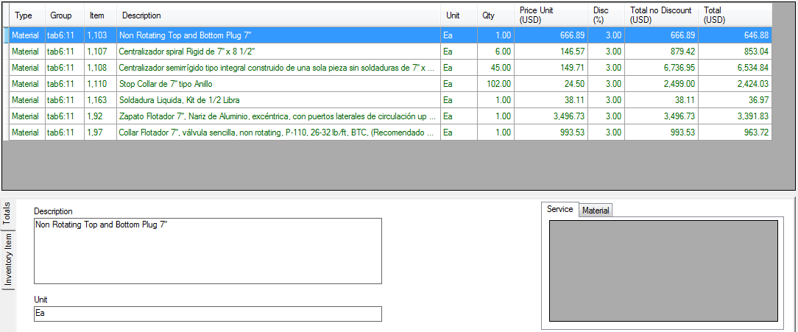

Information about CONTRACT Base Data. The field in red are obligatory.

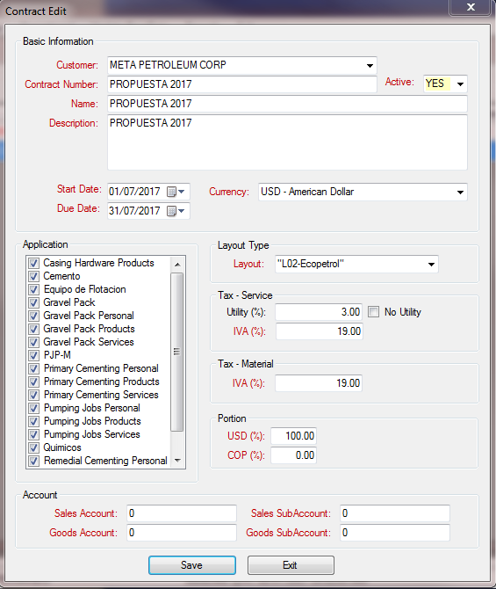

|  |  |  |
| --- | --- | --- |
| **Field** | **Type** | **Description** |
| Customer | Text | Customer Name (provided from CUSTOMER BaseData) |
| Active | Boolean | Yes (active) No (not active) |
| Contract Number | Text | Contract Number |
| Name | Text | Contract Name |
| Description | Text | Contract Description |
| Start Date | Date | Start Date of Contract (begin) |
| Due Date | Date | Due Date of Contract (end) |
| Currency | Text | Main Currency of the contract |
| Application | Text | Inventory Class that the Contract has participate |
| Layout | Text | Contract Layout (see the comments before) |
| Utility (Tax Service) | Number | Tax Service Utility Percentage |
| IVA (Tax Service) | Number | Tax Service IVA Percentage |
| IVA (Material) | Number | Tax Material IVA Percentage |
| Portion USD | Number | Portion USD used by L01 layout |
| Portion COP | Number | Portion COP used by L01 layout |
| Inventory SubAccount | Text | Created from SmartTickets |
| Sales Account | Text | Created from SmartTickets |
| Sales SubAccount | Text | Created from SmartTickets |
| Goods Account | Text | Created from SmartTickets |
| Goods SubAccount | Text | Created from SmartTickets |

### CONTRACT PRICE

The Base Data “CONTRACT PRICE” has information about the Item and Prices assigned by Customer´s Contract.

To access the Base Data “CONTRACT PRICE” open the menu “Customer” – “Contract Price”.

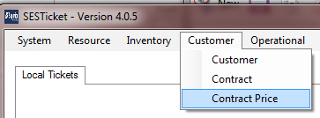

The screen will be shown with the all CONTRACT PRICE data available.

The Contract Price items are divided in: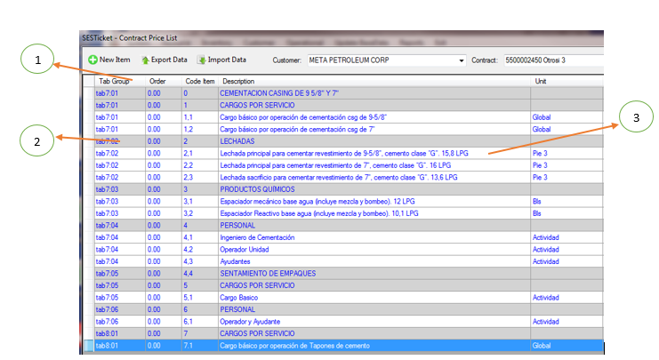

1. **Tab Group** – Each lines could be divided in groups called “Tab Group”. That way the contract prices items can be organized and it will be used on the reports.
2. **Header Item** – The header lines are used to organize the group information. The information is filling out with gray color and the values are not used in the calculations.
3. **Price Item** – The price lines are used in the tickets. Its values are been used in the Calculations.

Information about CONTRACT Base Data. The field in red are obligatory.

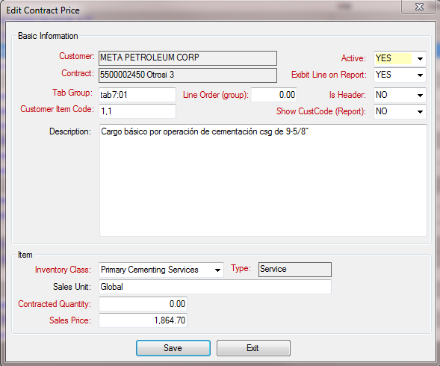

|  |  |  |
| --- | --- | --- |
| **Field** | **Type** | **Description** |
| Active | Boolean | Yes (active) No (not active) |
| Exhibit Line on Report | Boolean | Yes / No  If “YES” the line will be exhibit on the reports and the values will be calculated  If “NO” the line will not be exhibit on the reports and the values will not be calculated |
| Tab Group | Text | Contract Tab Group that the line will be included |
| Line Order (group) | Number | Line Position in the Tab Group. This position will be used in the search screen, Ticket Sales Item screen and the reports. |
| Is Header | Boolean | Yes / No  If “YES” the line is a header and cannot be used in the calculations.  If “NO” the line is a price line and can be used in the calculations. |
| Customer Item Code | Text | Customer Item Code defined on the Original Contract |
| Show CustCode (Report) | Boolean | Yes / No  If “YES” the Customer Item Code will be exhibit on the reports.  If “NO” the Customer Item Code will not be exhibit on the reports. |
| Description | Text | Contract Price Item Full Description |
| Inventory Class | Text | Inventory Class that the Contract has participate (if something is not showing check the contract in the field “Application”) |
| Sales Unit | Text | Sales Unit used in the Line |
| Contracted Quantity | Number | Created from SmartTickets |
| Sales Price | Number | Sales Price in the Line. The currency is the same of the Contract Header. |

### SITES

The Base Data “SITES” has information about the Superior Energy Sites.

To access the Base Data “SITES” open the menu “Operational” – “Sites”.

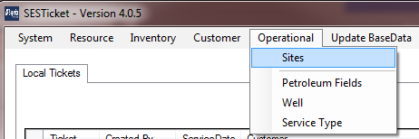

The screen will be shown with the all SITES data available.

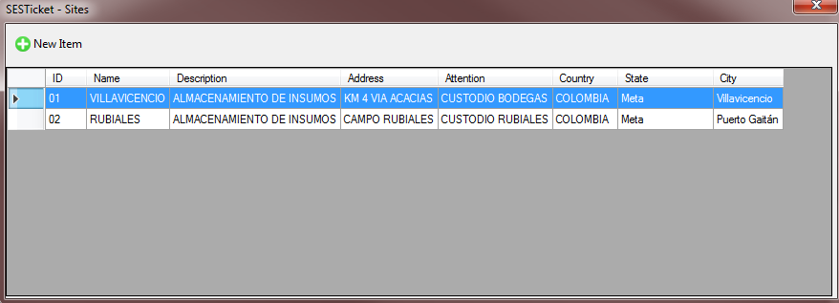

Information about SITES Base Data. The field in red are obligatory.

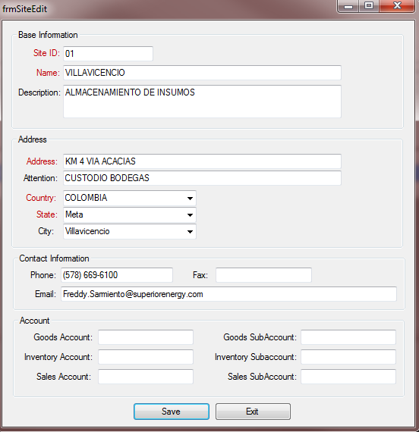

|  |  |  |
| --- | --- | --- |
| **Field** | **Type** | **Description** |
| Site ID | Text | Site Identification |
| Name | Text | Site Name |
| Description | Text | Site Description |
| Address | Text | Site Full Address |
| Attention | Text | Additional Information |
| Country | Text | Country |
| State | Text | State |
| City | Text | City |
| Phone | Text | Phone |
| Fax | Text | Fax |
| Email | Text | Email |
| Sales Account | Text | Created from SmartTickets |
| Sales SubAccount | Text | Created from SmartTickets |
| Goods Account | Text | Created from SmartTickets |
| Goods SubAccount | Text | Created from SmartTickets |
| Inventory Account | Text | Created from SmartTickets |
| Inventory SubAccount | Text | Created from SmartTickets |

### PETROLEUM FIELDS

The Base Data “PETROLEUM FIELDS” has information about the Petroleum Fields.

To access the Base Data “PETROLEUM FIELDS” open the menu “Operational” – “Petroleum Fields”.

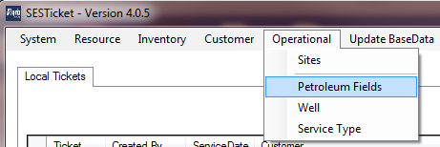

The screen will be shown with the all PETROLEUM FIELDS data available.

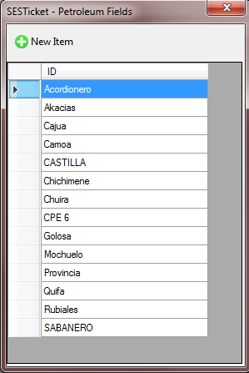

Information about PETROLEUM FIELDS Base Data. The field in red are obligatory.

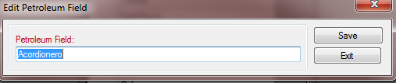

|  |  |  |
| --- | --- | --- |
| **Field** | **Type** | **Description** |
| Petroleum Field | Text | Petroleum Field name |

### WELL

The Base Data “WELL” has information about the Wells.

To access the Base Data “WELL” open the menu “Operational” – “Well”.

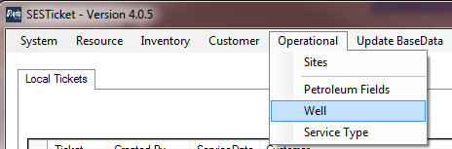

The screen will be shown with the all WELL data available.

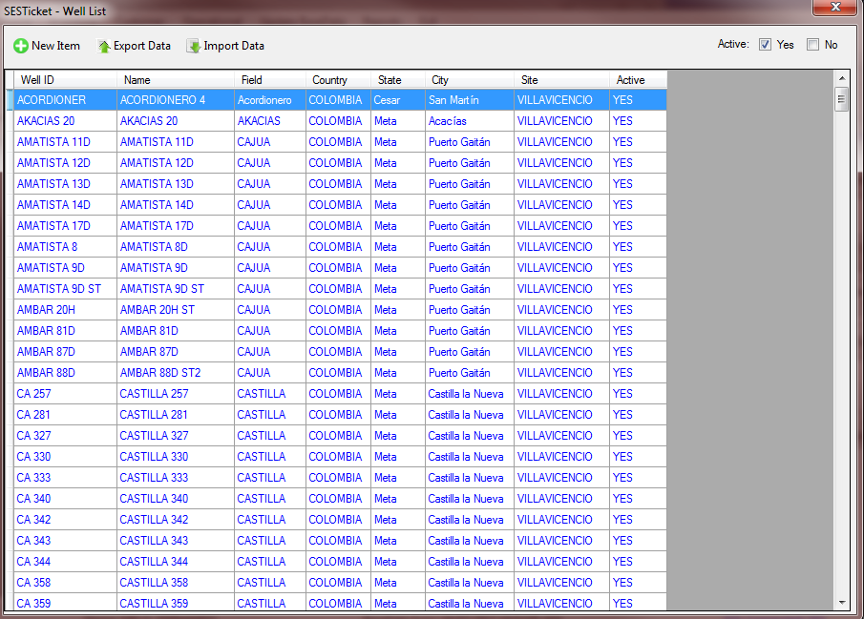

Information about WELL Base Data. The field in red are obligatory.

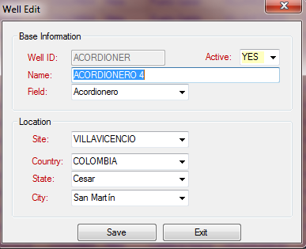

|  |  |  |
| --- | --- | --- |
| **Field** | **Type** | **Description** |
| Active | Boolean | Yes (active) No (not active) |
| Well ID | Text | Well Identification |
| Field | Text | Petroleum Field (from PETROLEUM FIELD BaseData) |
| Site | Text | Site Id (from SITE BaseData) |
| Country | Text | Country |
| State | Text | State |
| City | Text | City |

### SERVICE TYPE

The Base Data “SERVICE TYPE” has information about the Services Type.

To access the Base Data “SERVICE TYPE” open the menu “Operational” – “Service Type”.

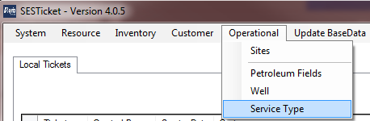

The screen will be shown with the all SERVICE TYPE data available.

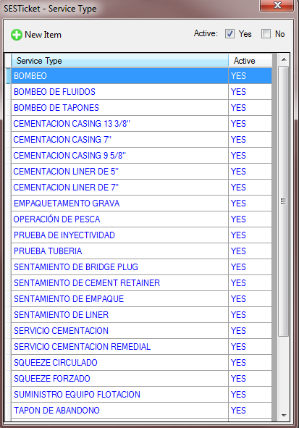

Information about SERVICE TYPE Base Data. The field in red are obligatory.

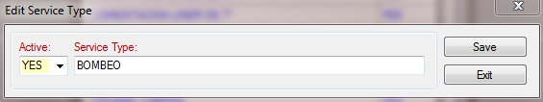

|  |  |  |
| --- | --- | --- |
| **Field** | **Type** | **Description** |
| Active | Boolean | Yes (active) No (not active) |
| Service Type | Text | Service Type Description |

### EXPORT UTILITY

The BaseData tables can be exported in Excel format and re-imported to update data and/or import new lines.

This tool is available only on these BaseData tables: EQUIPMENT, WORKER, INVENTORY ITEM, CONTRACT PRICE and WELL.

The export utility is available on the menu called “Export Data” in each BaseData screen.

**To Export Data:**

1 – Open the BaseData that you want export and click on “Export Data” menu.

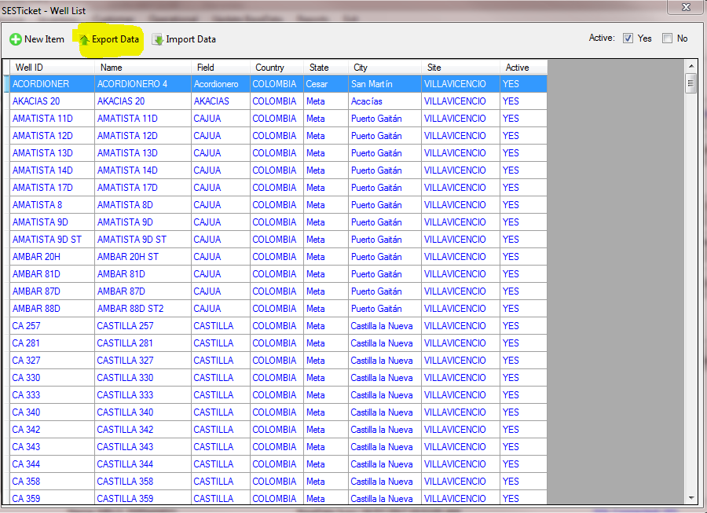

2 – The export utility will open with these options:

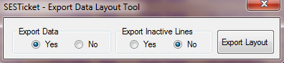

Export Data: If you want export all lines (“YES”) or only the template empty (“NO”)

Choose the options and click in “Export Layout”. At this moment the system will ask the path to save the file.

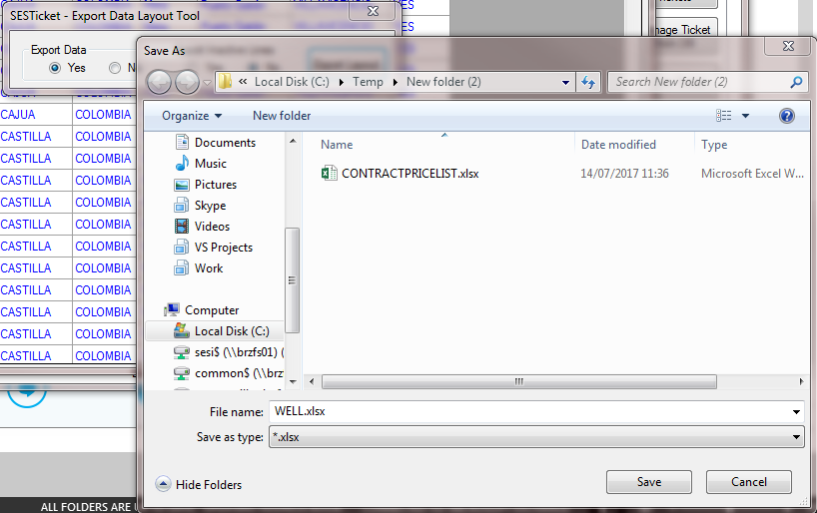

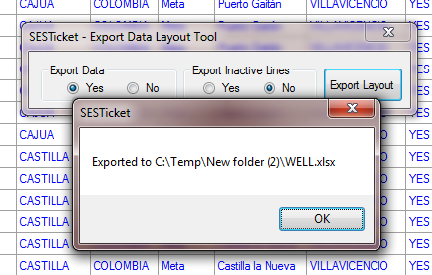

3 – The data is available on the path.

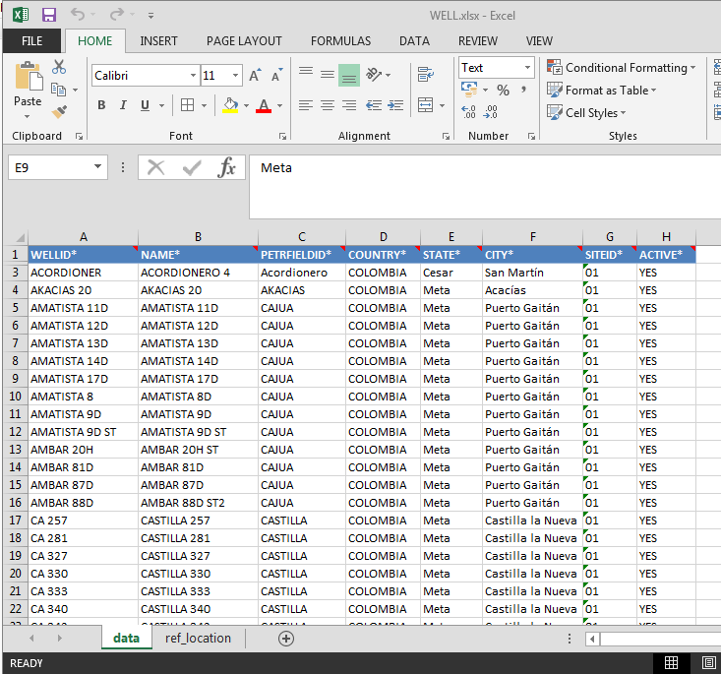

### IMPORT UTILITY

After export data and change all information the information can be imported again through Import Utility.

Attention:

* The Import Utility imports **only** Excel files that generated by Export Utility
* The column datatype must be respected (text, number, etc.). If have doubt check the comments in the Column Header
* Don’t change the column header name and don’t change/deleted the line #2 (in hidden). This column is used to control.

This tool is available only on these BaseData tables: EQUIPMENT, WORKER, INVENTORY ITEM, CONTRACT PRICE and WELL.

The export utility is available on the menu called “Import Data” in each BaseData screen.

**To Import Data:**

1 – Open the BaseData that you want export and click on “Import Data” menu.

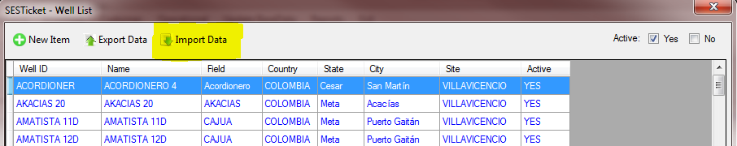

2 – Click on button “Open File” and choose the file that wants to be imported.

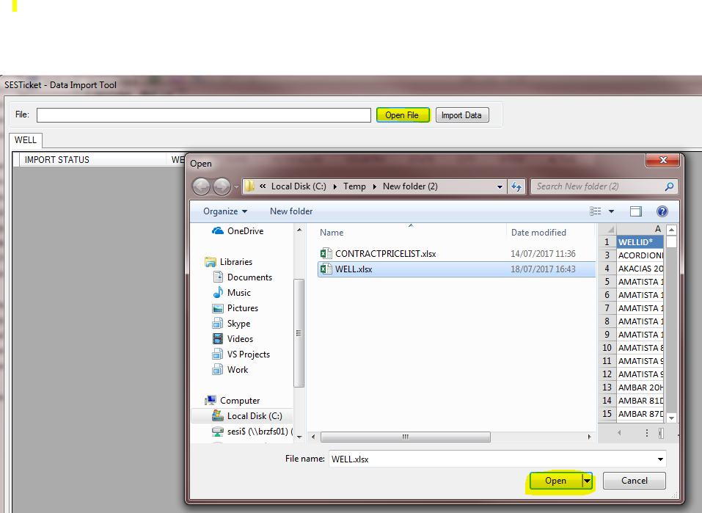

3 – Click in “Import Data”. At this moment the system is checking the information provided by the Excel file.

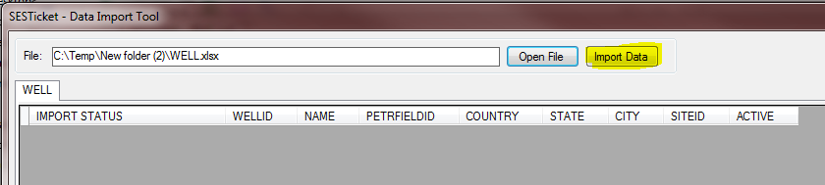

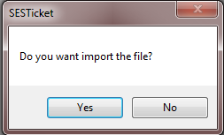

4 – If the system find something wrong, a message is exhibit and you should analyze it and fix it. After that, you can re-import the file again.

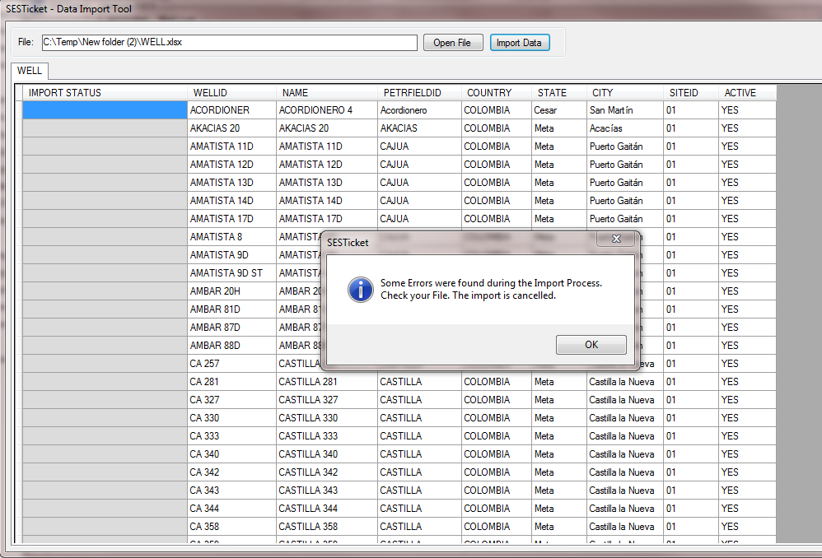

The line with problem is identified on column “IMPORT STATUS”. You can getting more information with double click on the registry.

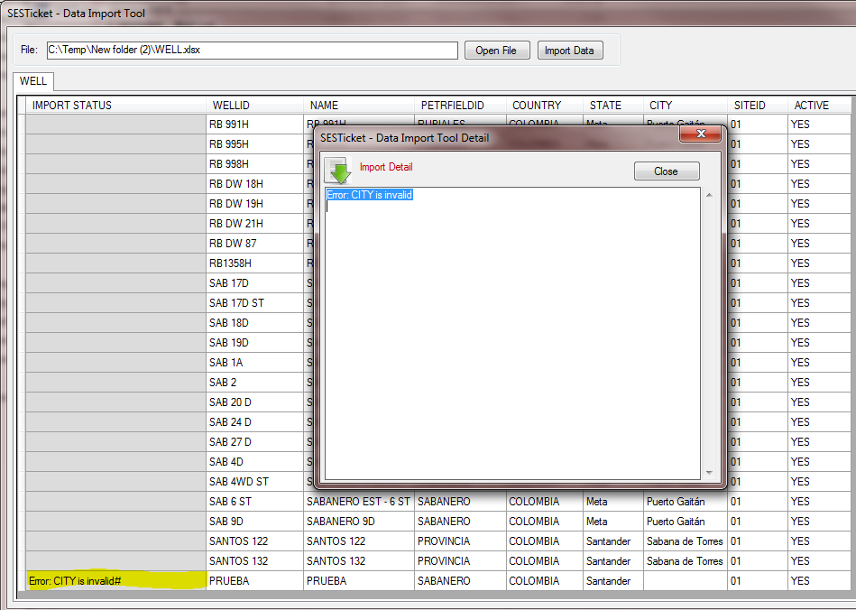

5 – If the system does not finding any problem so the Synchronization is made and the Import Status will resume the import process.

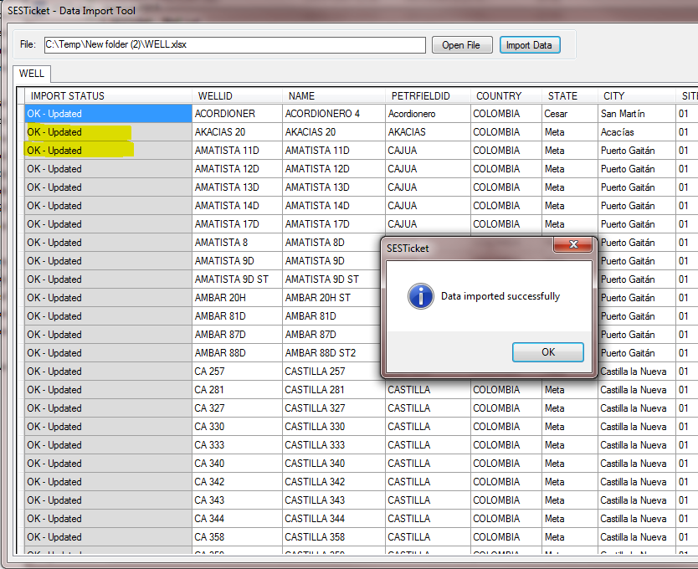

## TICKET

In this chapter you will finding all information about the Service Tickets.

### UNDERSTAND THE TICKET

When the Superior Engineer proceed with some job on the customer the information about Sales Item, Job work, workers and inventories are generated. The information is storage on the system and it’s called Ticket.

The Ticket always is associate with Customer and Contract. The service prices is defined by Account Receivable on Colombia and the information is inputted on the SESTicket through CONTRACT and CONTRACT PRICE BaseData.

The Ticket can 3 different status:

|  |  |  |
| --- | --- | --- |
| Status | Identified by Color | Description |
| Open | **Green** | When the ticket has open status its mean that the activities are not finished yet. |
| Closed | **Blue** | When the ticket has Closed status its mean that the activities are finished and anything can be changed. |
| Canceled | **Red** | When the ticket has Canceled status its mean that the System Administrator canceled the Ticket and the information is not more necessary. |

The Main Screen exhibit the information of all Tickets created locally. This tickets is synchronizing with Database Server when the user is connected on the Superior network. The ticket colors are respected the Ticket status.

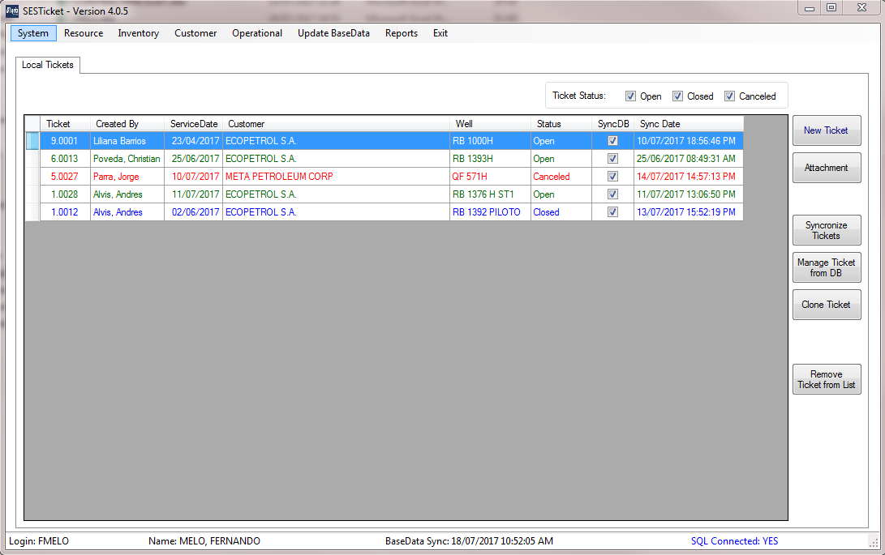

The next chapters you will have the knowledge about the Ticket administration.

### CREATE A NEW TICKET

1 – On the Main Screen, click in “New Ticket”

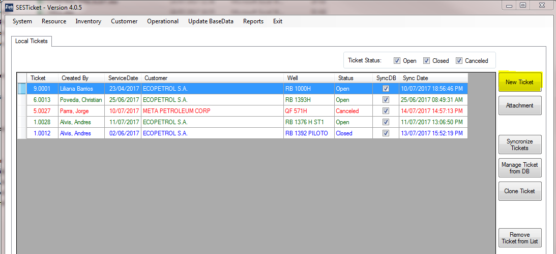

2 – At this moment, the screen is showing. Fill in the fields on “Details” tab. The field in red are obrigatories.

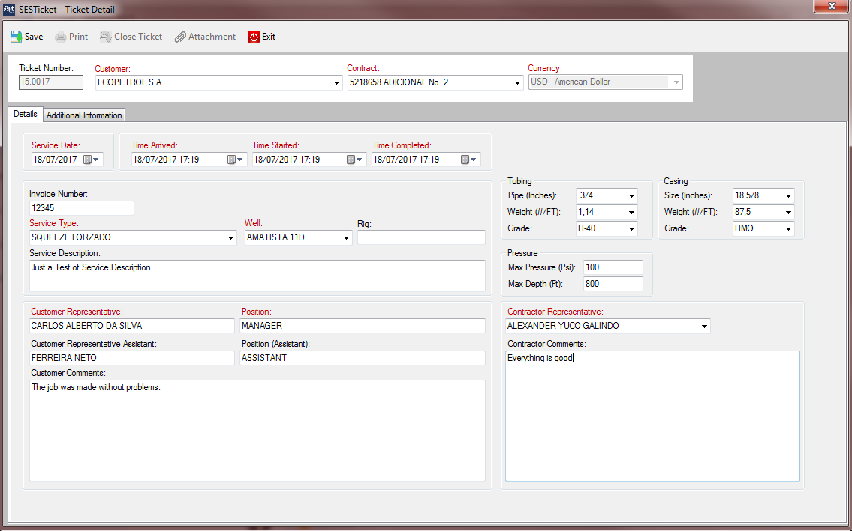

|  |  |
| --- | --- |
| **Field** | **Description** |
| Ticket Number | Its automatically generated based on the User ID (see the USER BaseUser) |
| Customer | Customer Name (provided from CUSTOMER BaseData) |
| Contract | Customer´s Contract (from CONTRACT BaseData).  Only Active contracts and/or due date not expired. |
| Service Date | Service Date |
| Time Arrived | Date/Time that arrives on the customer |
| Time Started | Date/Time that the activities started on the customer |
| Time Finished | Date/Time that the activities were finished on the customer |
| Invoice Number | Invoice Number provided by customer |
| Service Type | Service Type BaseData (only “Activity” will appear on this combo box) |
| Well | Well BaseData (only “Activity” will appear on this combo box) |
| Rig | Rig Information |
| Service Description | Full Service Description |
| Customer Representative | Name of Customer Representative – Responsible for the Job |
| Position | Customer Representative Position |
| Customer Representative Assistant | Name of Customer Representative Assistant |
| Position (Assistant) | Customer Representative Assistant Position |
| Customer Comments | Customer Comments – This information will appear on the Ticket report. |
| Contractor Representative | Superior´s Contractor Representative |
| Contractor Comments | Superior´s Contractor Comments – This information will appear on the Ticket report. |
| Tubing – Pipe (Inches) | Tubing Pipe (Inches) |
| Tubing – Weight (#/FT) | Tubing Weight (#/FT) |
| Tubing – Grade | Tubing Grade |
| Casing – Size (Inches) | Casing Size (Inches) |
| Casing – Weight (#/FT) | Casing Weight (#/FT) |
| Casing – Grade | Casing Grade |
| Pressure – Max Pressure (Psi) | Pressure Max Pressure (Psi) |
| Pressure – Max Depth (Ft) | Pressure Max Depth (Ft) |

3 – After click in “Save” the information will be saved. The message “Ticket Saved but not Synchronized” mean that the ticket was saved but the information is only one on the computer.

At this moment, the new tabs “Sales Item”, “Job Log”, “Equipment” and “Workers” will appearing.

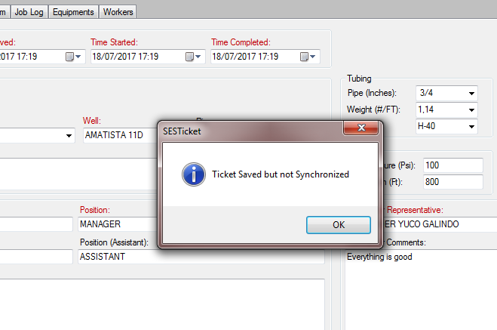

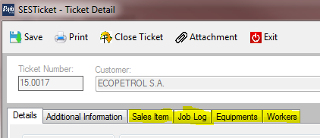

### ADDICTIONAL INFORMATION

The tab “Additional Information” is a memo area that can be used to include the any information for internal control. This information will not appear in Ticket Reports.

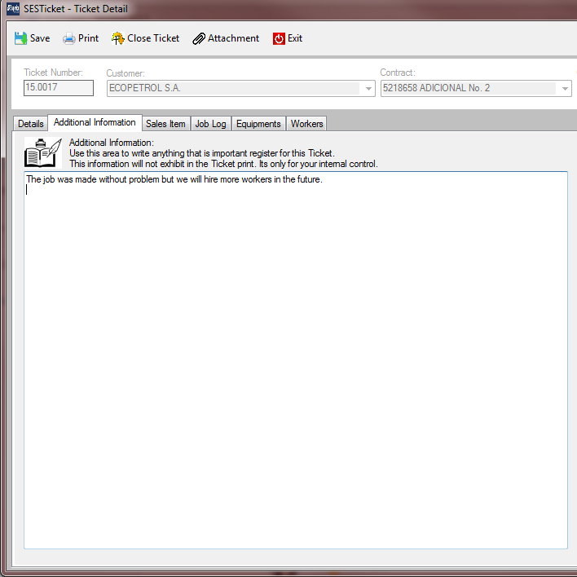

### SALES ITEM

The tab “Sales Item” is responsible to get the Contract Prices Items and make the calculations for the Customer.

The Sales Item screen change depends on the Contract Layout defined (see the chapter 5.4.1 CONTRACT)

**Layout: L01-Meta Petroleum**

* The tickets does not permits give Discounts on the Sales Items.
* Ticket Sales Item will calculate the Portions.

Example:

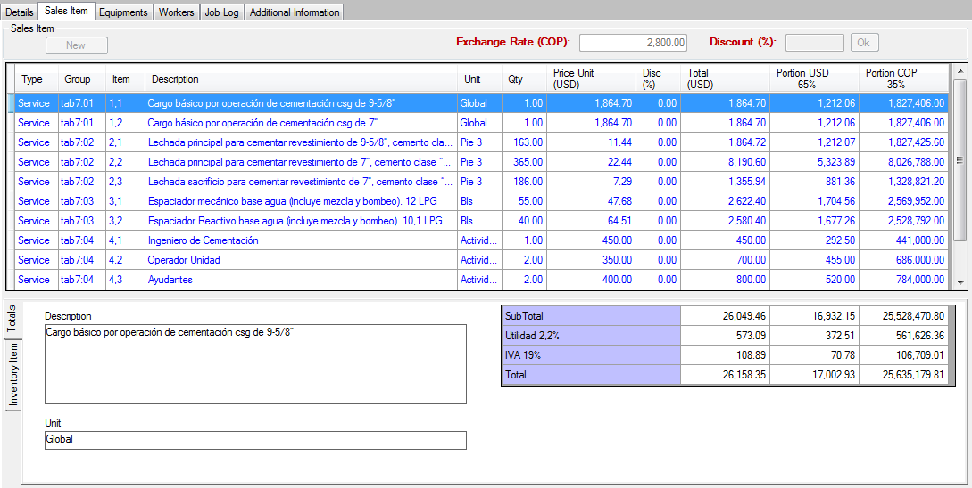

**Layout: L02-Ecopetrol**

* The tickets are available to generate Discounts
* The Material and Services taxes and totals are generated independents of each other.
* This layout does not use the Portion

Example:

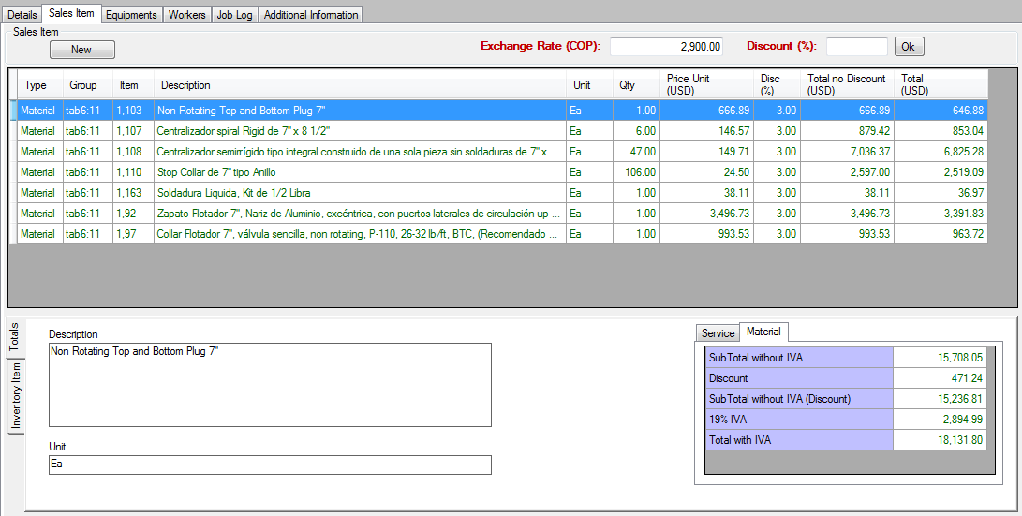

**UNDERSTAND THE SALES ITEM SCREEN**

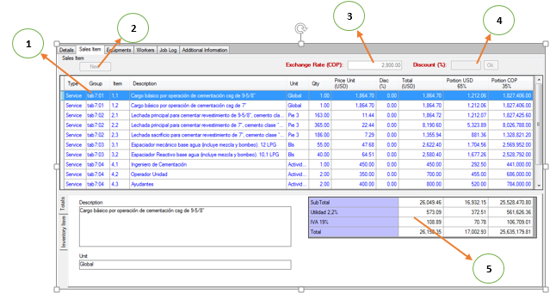

**1 – Sales Item Grid:** Each line is a Contract Price Item with prices, discounts, etc.

**2 – “New” button:** Used to include a new Contract Price Item

**3 – Exchange Rate (COP):** This Exchange Rate in COP (Colombia Pesos) used in the conversion to USD.

**4 – Discount (%):** Apply discount (%) in all Contract Price Item

**5 – Totals Grid:** Totals of the all lines of Sales Item Grid

#### ADD SALE ITEM

1 – Inform the “Exchange Rate (COP)”. Without this information, the screen below will advise you about it.



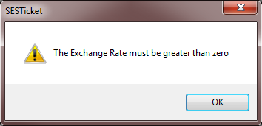

2 – Click on Button “New”



3 – The “Edit Sales Item” will appearing. Click on button “Search” to choose the new Contract Price Item.

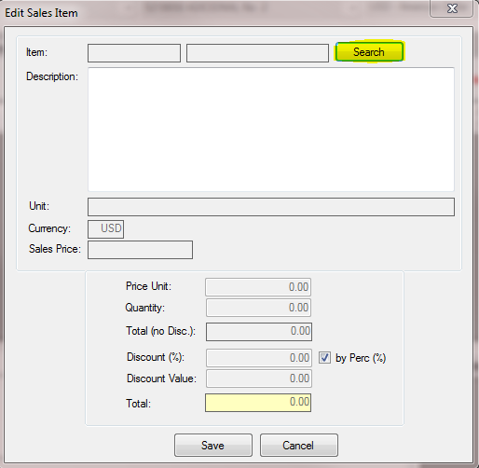

4 – In the “Search Contract Price Item” screen choose the Item with double click.

Obs.: The lines in gray are Headers and it not permit to choose.

Just Contract Price Lines with Active equal “YES” will exhibit.

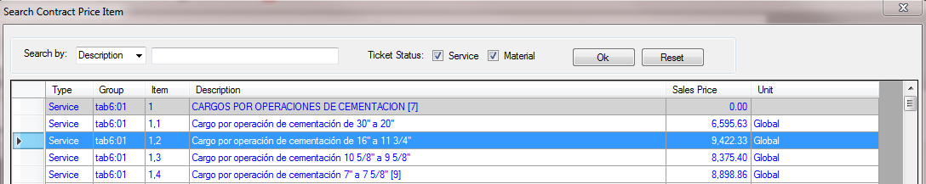

5 – Edit the following fields and click in “Save”.

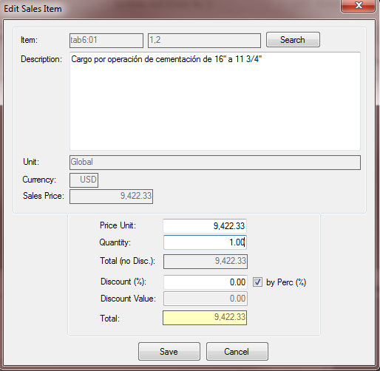

|  |  |
| --- | --- |
| **Field** | **Description** |
| Description | The system will bring the original description used on the contract. You can change this description as well |
| Price Unit | The system will bring the original Price Unit. You can change this price unit as well. |
| Quantity | Quantity contracted |
| Discount (%) | If the checkbox “by Perc(%)” is checked you can inform the discount (%) and the Discount Value will be calculated. |
| Discount Value | If the checkbox “by Perc(%)” is not checked you can inform the discount value and the Discount (%) will be calculated. |

6 – After Save, the line is available on the Grid.

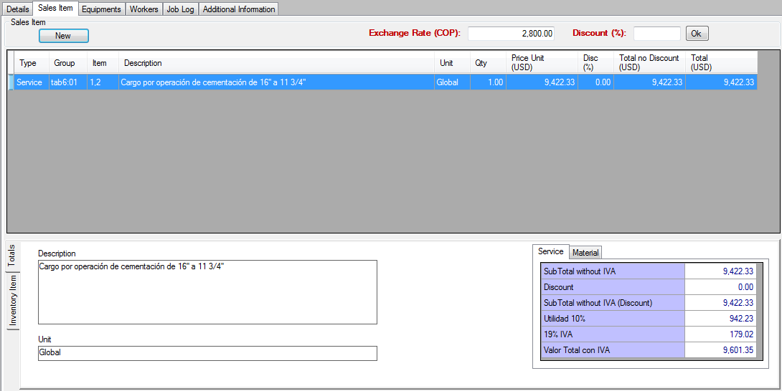

#### EDIT SALE ITEM

To edit any item just a double click in any line. Edit the values and “Save”.

#### DELETE SALE ITEM

To delete any item just a double click in any line. In “Edit Sales Item” screen click in “Delete”. This action is irreversible.

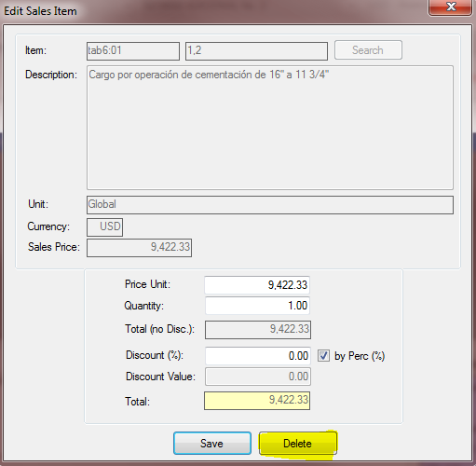

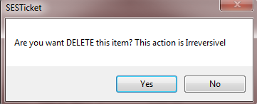

#### DISCOUNTS

There are two ways to apply discounts:

1. Discount on Item level – This discount is applied on the specific line through “Sales Item Edit” screen (see Chapter 5.5.1.1 – Add Sale Item)
2. Discount in all lines – This discount is applied in all lines of the sales item grid. For that, inform the discount on the field “Discount (%)” and click in “ok”.

Attention: This discount will be applied in ALL lines. If some line has a specific discount, it will be replaced by this globally discount.

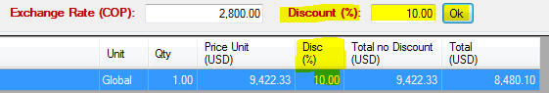

#### EXCHANGE RATE (COP)

As we talked on chapter “Chapter 5.5.1.1 – Add Sale Item”, the Exchange Rate (COP) is an obligatory value used by conversions between COP x USD.

When a new item is created this exchange rate is informed. But if you have a necessity to change it just change the field “Exchange Rate (COP)” and press “enter”. All lines will be re-calculated with new rate.



### INVENTORY ITEM

The Inventory Items are product used to attend some Sale Item. For that the “Inventory Item” is a tab on the “Sales Item” main tab and it is associated with each Sales Item line.

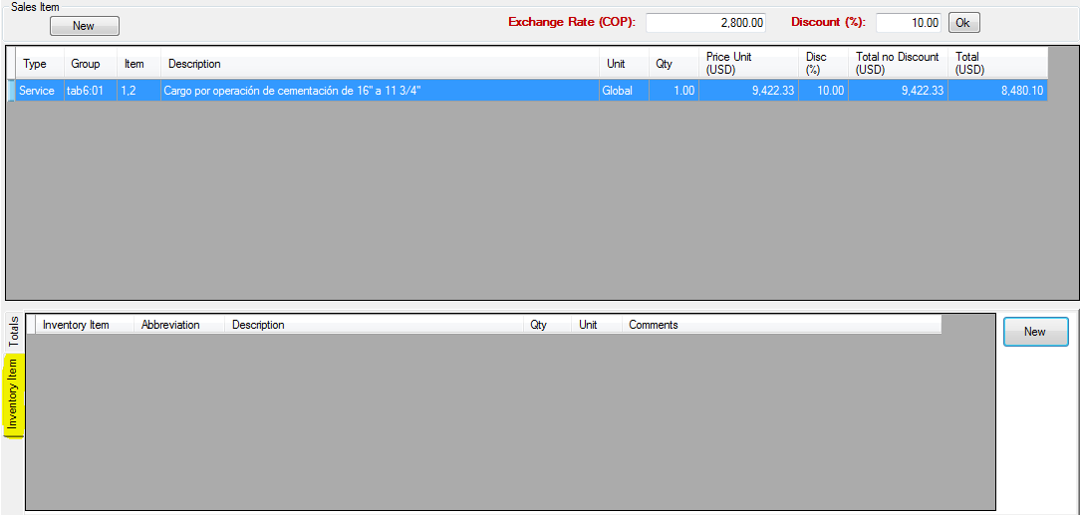

#### NEW INVENTORY ITEM

1 – Access the tab “Sales Item”, choose the Sales Item line, access the “Inventory Item” tab and the button “New”.

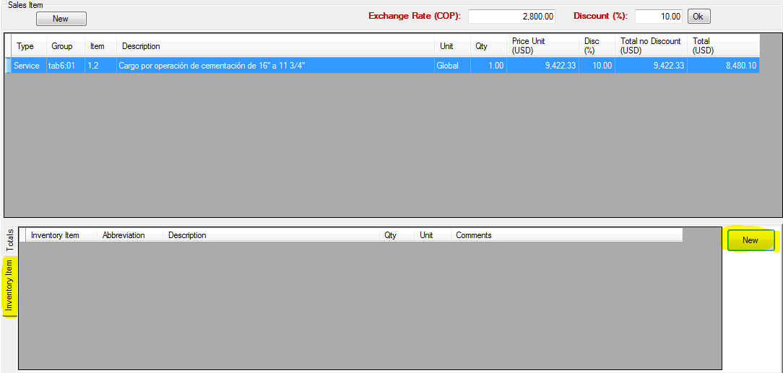

2 – “Inventory Item” screen, click in “Search”

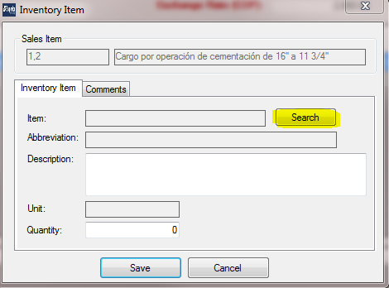

3 – “Search Inventory Item” screen, double click on the item that you want include.

Obs.: Just Contract Price Lines with Active contract equal “YES” will exhibit.

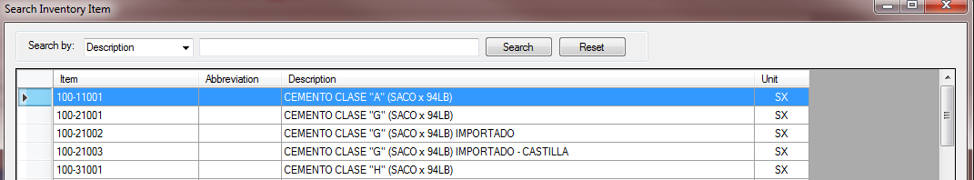

4 – Fill in the fields and click in “Save”. You can include a comments on the tab “Comments”.

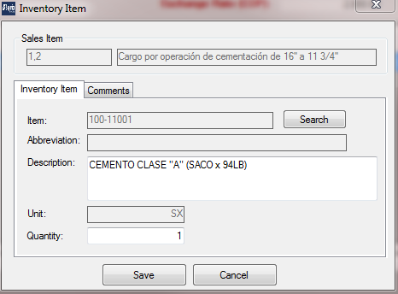

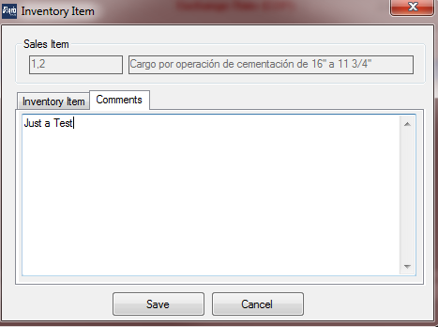

5 – After that the Inventory Item will appear on the grid.

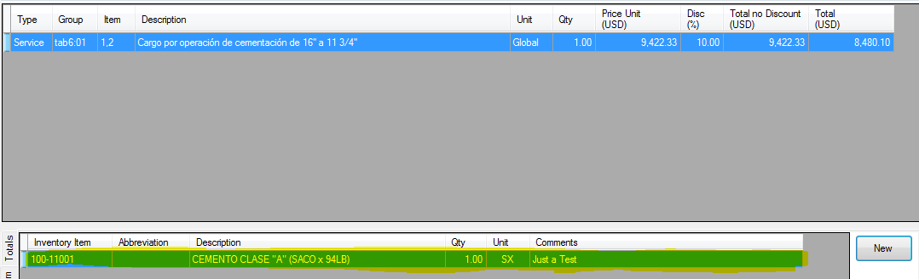

#### EDIT INVENTORY ITEM

To edit any item just a double click in any Inventory Item line. Edit the values and “Save”.

#### DELETE INVENTORY ITEM

To delete any item just a double click in any line. In “Inventory Item” screen click in “Delete”. This action is irreversible.

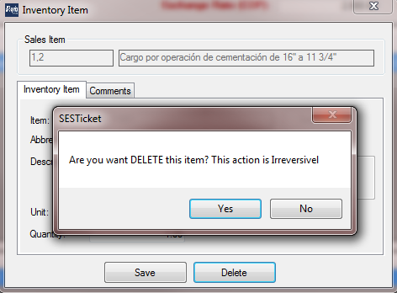

### EQUIPMENT

The Equipment tab contains all equipment (truck, batch mixes, etc.) used in the Ticket.

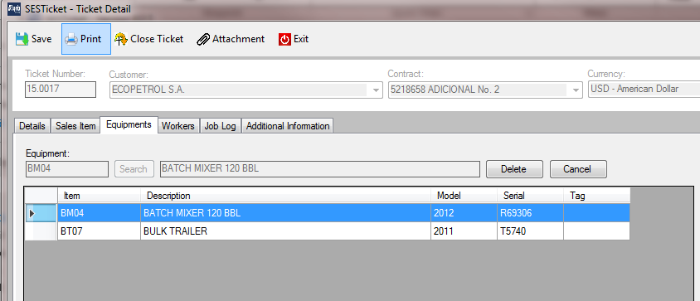

#### ADD EQUIPMENT

1 – Access the tab “Equipment” and click on button “Search”. The Search Screen will showing with all equipment disponible. Just double click on the equipment.

Obs.: Just Equipment Lines with Active equal “YES” will exhibit.

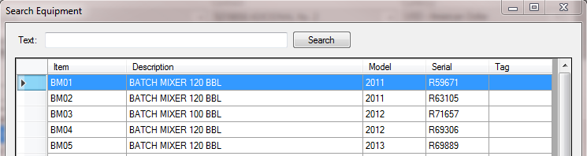

2 – Click on button “Add”. After that the Equipment is include on the list.

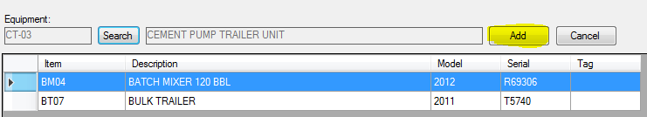

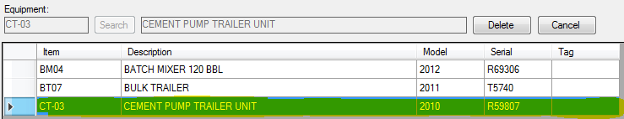

#### DELETE EQUIPMENT

To delete any Equipment just select on the line on the grid and click on the button “Delete”. This action is irreversible.

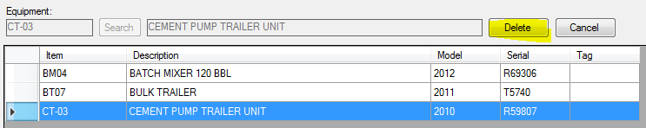

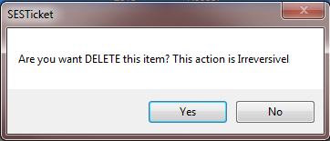

### WORKERS

The Workers tab contains the Workers that made some job in the Ticket. This option is used to keep track the worker, date worked, hours worked.

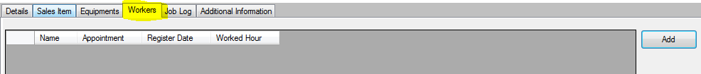

#### ADD WORKER

1 – Access the tab “Workers” and click on button “Add”.



2 – “Ticket Worker” screen click on button “Search”.

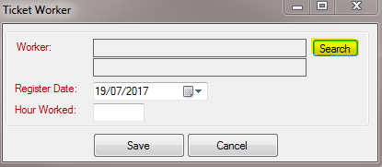

3 – The Search Screen will showing with all Workers available on the system. Just double click on the worker.

Obs.: Just Workers lines with Active equal “YES” will exhibit.

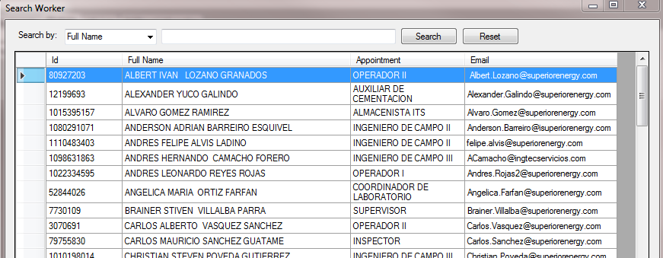

4 – Fill in the field and click in “Save”.

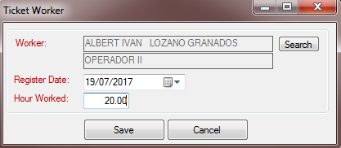

|  |  |
| --- | --- |
| **Field** | **Description** |
| Register Date | The Date worked on the customer by Worker |
| Hour Worked | Total hours worked by Worker. |

#### EDIT WORKER

To edit any item just a double click in any Worker line. Edit the values and “Save”.

#### DELETE WORKER

To delete any item just a double click in any line. In “Worker” screen click in “Delete”. This action is irreversible.

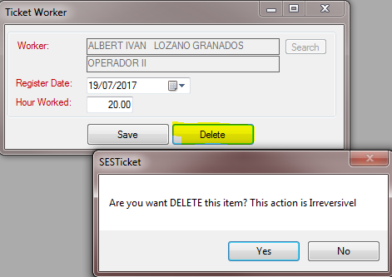

### JOB LOG

The Job Log tab is the area that keep track the information about Job Log history made by Engineers.

This information will be used on the Job Log report.

It is divide in 2 areas: Header and Activities (lines).

#### NEW JOB LOG

1 – Access the tab “Job Log” and the click in “New Log” button.

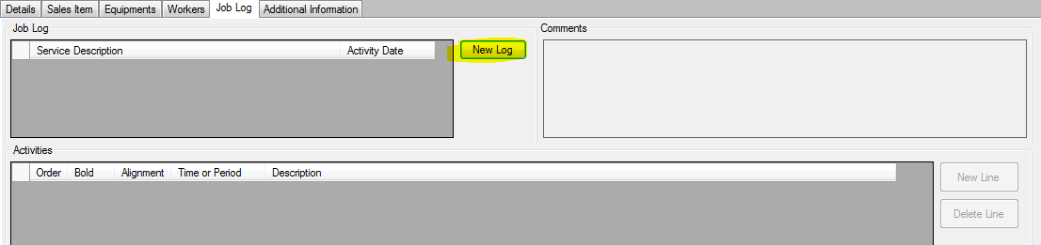

2 – Fill in the fields and click in “Save”.

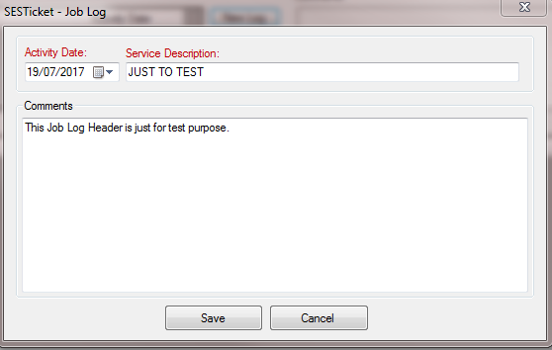

|  |  |
| --- | --- |
| **Field** | **Description** |
| Activity Date | Job Date |
| Service Description | Job Description |
| Comments | Comments |

3 – After save, the new Job Log Header is available and new Activities can be included. Click on button “New Line” in “Activities” area.

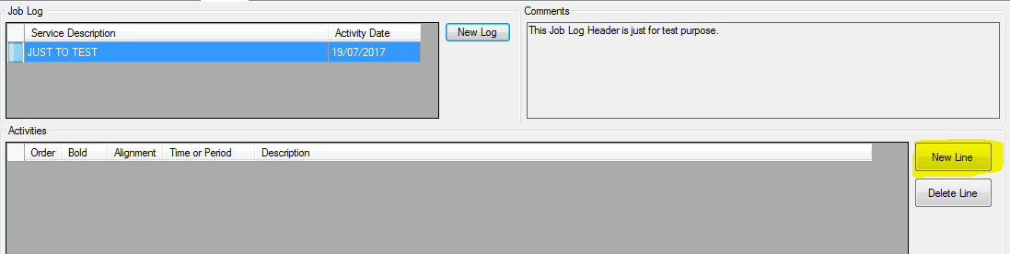

4 – The new line is inserted on Activities grid. Each field can be editable directly on grid. It’s an auto saved grid.



|  |  |
| --- | --- |
| **Field** | **Description** |
| Order | Line order (this order will be used on Job Log report) |
| Bold | If Checked mean that the line will appearing in Bold on the Job Log Report  If Not Checked mean that the line will not appearing in Bold on the Job Log Report |
| Alignment | The alignment of the line on the Job Log Report  (Left, Middle or Right) |
| Time or Period | It’s a text field to fill in with the Job period |
| Description | Memo field to input all information about the job made on the period. |

#### EDIT JOB LOG

**Header:** To edit the job log header just a double click in any Job Log line. Edit the values and “Save”.

**Activities:** It’s an auto save and always enable to edit any data directly on the grid

#### DELETE JOB LOG

**Header:** To delete Job Log header just a double click in any line. In “Job Log” screen click in “Delete”. This action is irreversible and will delete the Job Log header and it’s the Activities associated.

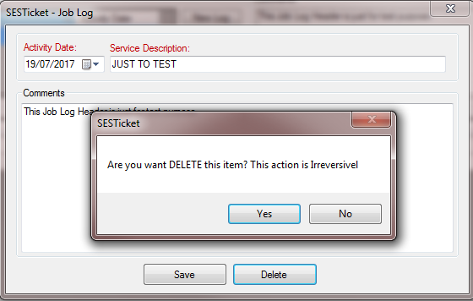

**Activities:** Choose the line and click in “Delete Line” button.

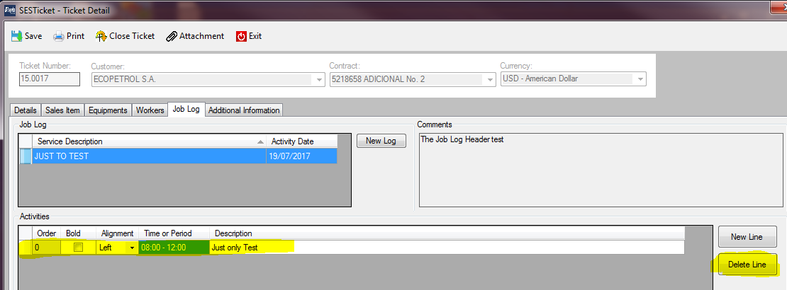

### REPORTS

The Report menu is an important area. This area contains the all reports used by Tickets. This chapter will explain each report.

The reports are available on the Ticket menu “Print”

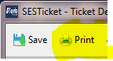

All reports screen has a menu to print, export, etc.

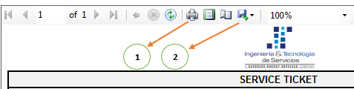

1 – Print Button

2 – Export Option: With this option you can export to Excel, Word, PDF and Excel.

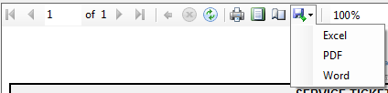

#### TICKET SALES ITEM

The report “Ticket Sales Item” provides the invoices with the all information by Sales Item screen (see the chapter 5.5.1 – Sales Item).

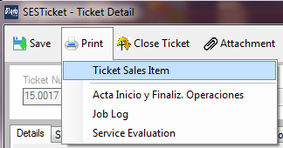

This report has different Ticket Layout prints and options. Just select on the layout on “Ticket Layout” combo box and the report will be appear.

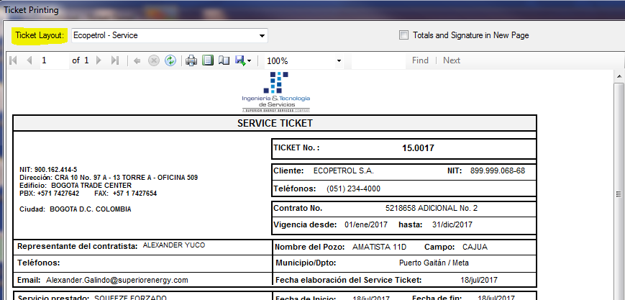

#### ACTA INICIO Y FINALIZ. OPERACIONES

The report “Acta Inicio Y Finaliz. Operaciones” has a contract that be assign to customer when the activity is finished (“Inicio”) and finished (“finalization”)

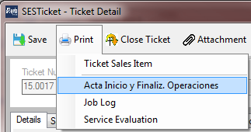

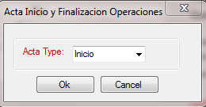

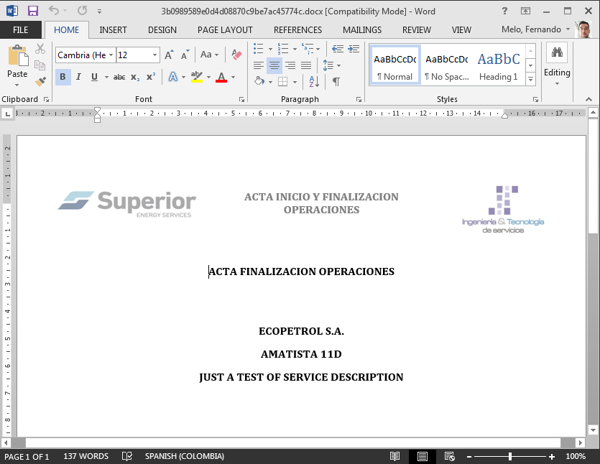

#### JOB LOG

The report “Job Log” is responsible to print the Job Log information (see chapter 5.5.5 – Job Log).

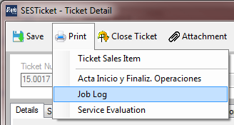

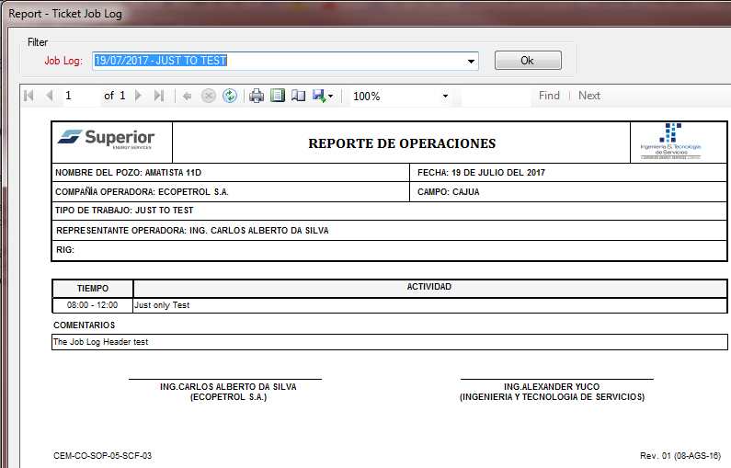

#### SERVICE EVALUATION

The report “Service Evaluation” is used to get customer about Service Evaluation (HSEQ).

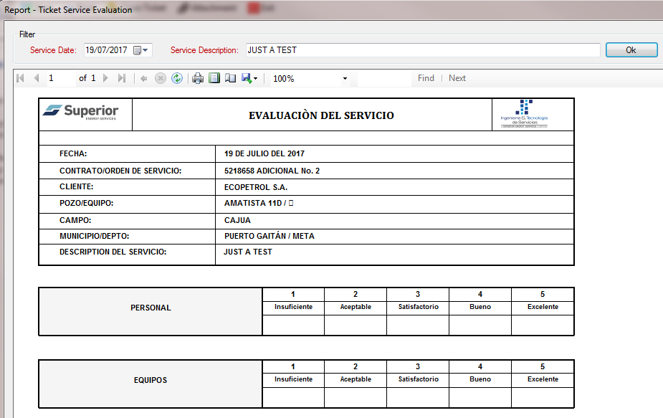

### CLOSE TICKET

When the Service Ticket is totally finished the action “Close Ticket” is necessary. That way no more updates can be made (just Attachment).

To Close Tickets access the Ticket and click on menu “Close Tickets”. If the computer is connected on the Superior network the synchronization will be started.

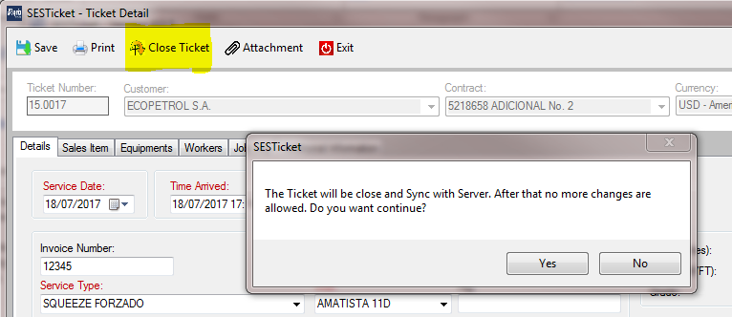

Note: Just the System Administrator can Re-Open the Ticket.

### CLONE TICKET

The SESTicket system has improved with Clone Ticket option.

To Clone Ticket access the Main Screen, select a ticket that you want and click on button “Clone Ticket”.

After that inform the Service Date and click in Ok.

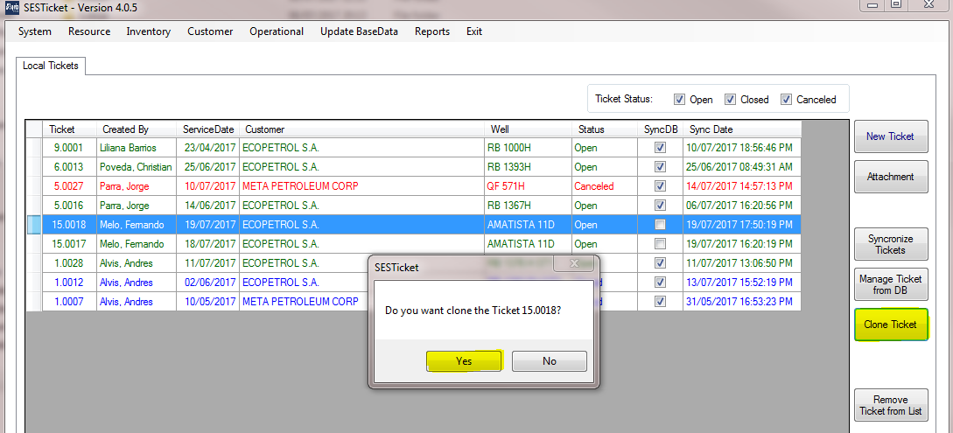

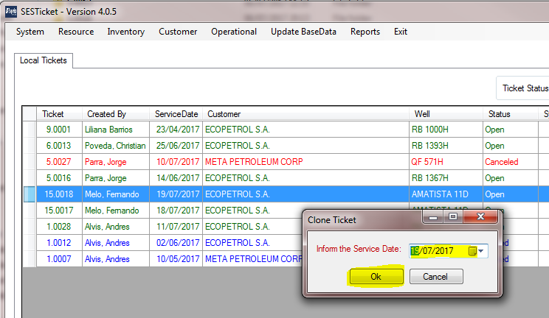

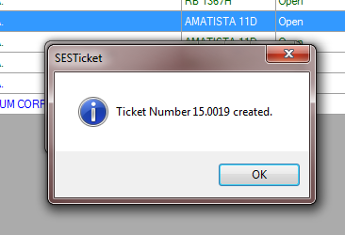

### ATTACHMENT

The SESTicket system enables to include documents as attachments in the Ticket.

When the computer is connected on the Superior network the files are synchronized automatically with the server. That way, the documents can be share with other users.

The files are attached a Ticket level. That mean each ticket has its own files.

Has 2 ways to access the Attachment option:

1 – Main Screen – “Attachment” button

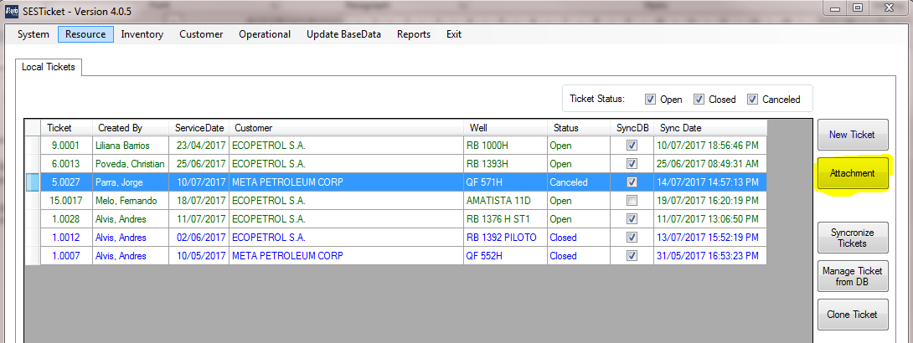

2 – Ticket Screen – menu “Attachment”

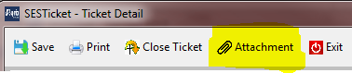

#### SCREEN INFORMATION

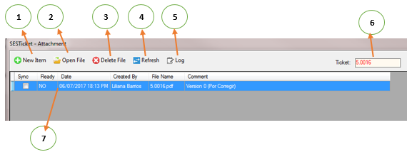

1 – New File – Used to include new files on the Ticket

2 – Open File – Used to open file when it is available on the machine. If not, the synchronization is made to get the file from server.

3 – Delete File – Delete file from Ticket (local and server)

4 – Refresh – Refresh the grid file information

5 – Log – Synchronization Logs

6 – Ticket ID

7 – File Grid – The file grid has the information about the files.

|  |  |
| --- | --- |
| **Column** | **Description** |
| Sync | The synchronization status.  Checked - file is already synchronized locally and the server (both)  Not Checked – file is not synchronized yet (locally and/or server) |
| Ready | YES – File is available for viewing  NO – File is not available for view (its only in Server) |
| Date | Attachment Date time |
| Created by | Person who included the file |
| File Name | Full file name |
| Comment | File comments |

#### INCLUDE FILES

1 – Select the Ticket and click in “Attachment”. At this moment the Attachment screen will appear. Click on button “New Item”

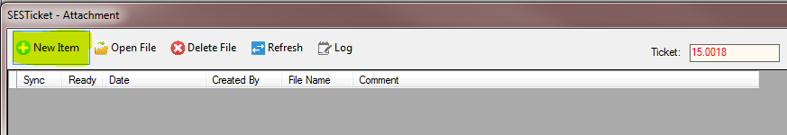

2 – Choose the File. Include the comments and click in “Save”.

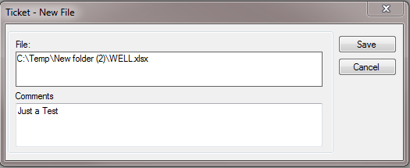

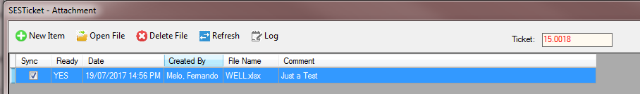

#### OPEN FILES

To open files the column “Ready” should be equal “YES”.

If the column is equal “NO” the system will ask if you want to get the file from server through synchronization.

You can use the “Refresh” button to know that the server copy is done.

To open file click on file and click on “Open File” menu.

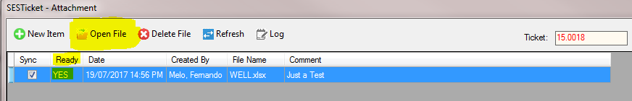

#### DELETE FILES

To delete files choose the file and click on menu “Delete File”.

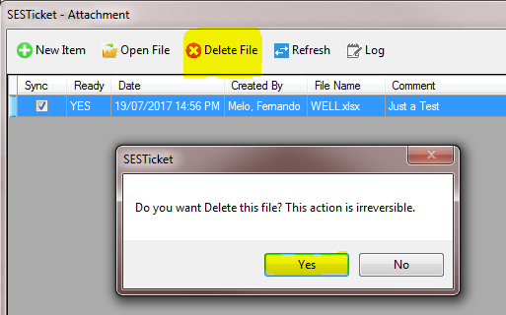

#### SYNC LOG

The attachment synchronization process generates a log. This log is used to find out some problems on the process.

To access this option click on menu “Log”.

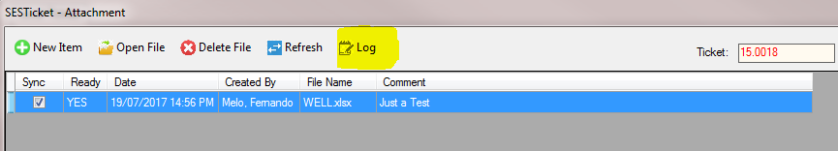

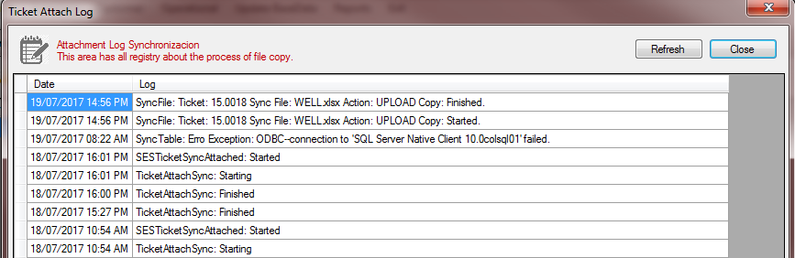

### MANAGE TICKET FROM DB

The Manage Ticket from DB has information about all tickets made and synchronized by Engineers.

This option is enabled only when connected on Superior network.

On this screen you can:

* Viewer tickets synchronized (ALL TICKETS System Administrator only)
* Import Ticket to Local Base
* Re-Open tickets closed
* Cancel Tickets

This option is located on Main Screen – “Manage Ticket from BD”

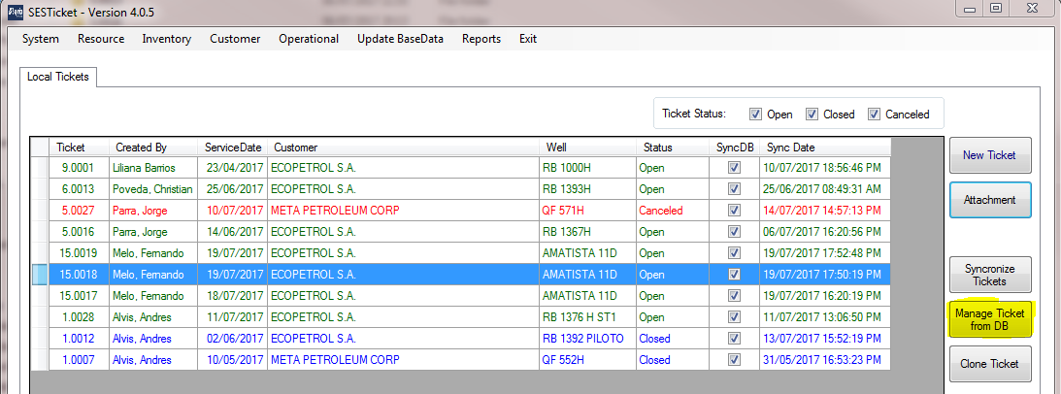

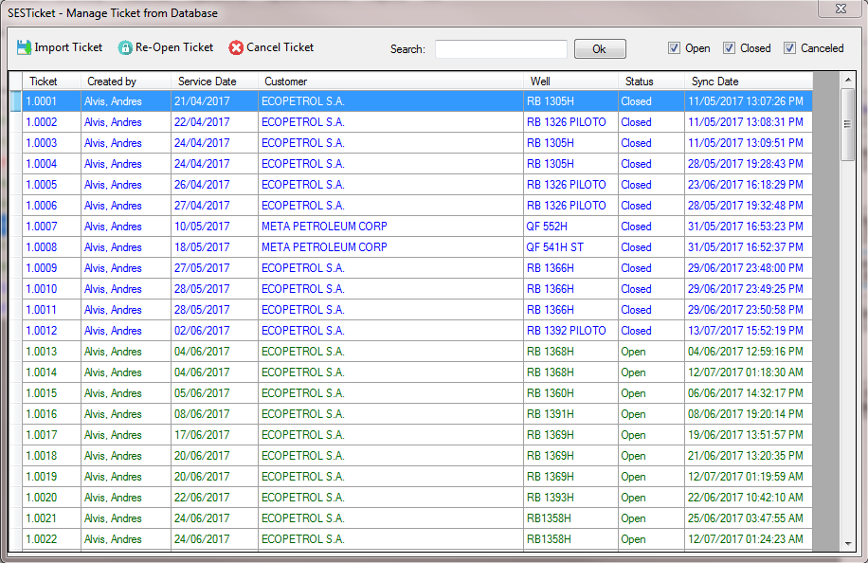

#### IMPORT TICKET

To import the ticket just select one and click in “Import Ticket”.

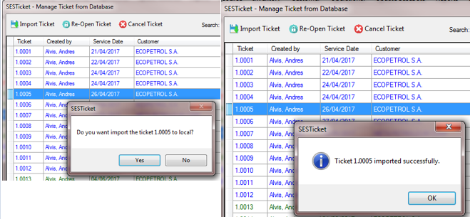

#### RE-OPEN TICKET

When the Ticket is closed no more updates are available but sometimes some adjusts are necessary. For that, the ticket should be re-opened. Only the System Administrator can re-open tickets.

To re-open ticket: select the ticket with Status “Closed” and click in “Re-Open Ticket” menu.

The screen will appear asking the Authorized and comment. After fill in this information click in “Re-Open” and the ticket will re-opened.

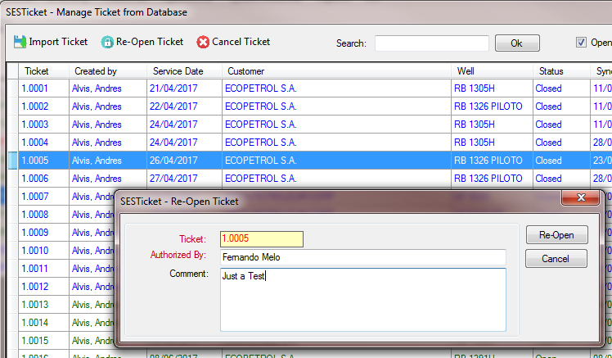

#### CANCEL TICKET

Sometimes the ticket is not used to or have issues. For that the ticked should be canceled.

Only the System Administrator can cancel tickets.

To re-open ticket: select the ticket and click in “Cancel Ticket” menu.

The screen will appear asking the Cancel Reason. Click in “Ok”.

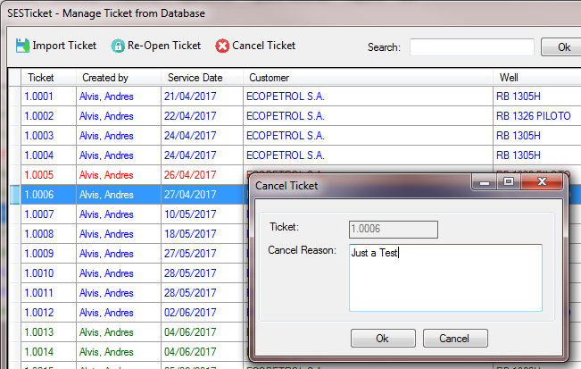

The cancel details can be consulted on the Ticket – button “Details” on header.

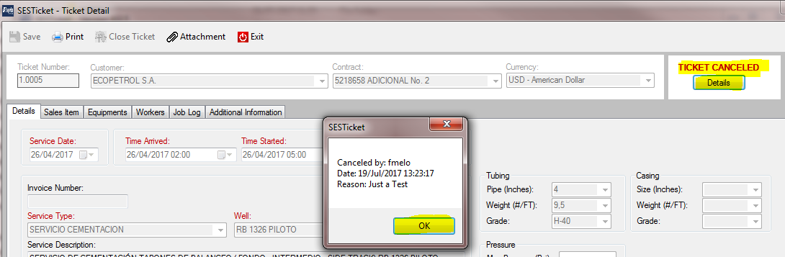

## REPORTS (MANAGER REPORTS)

The SESTicket has reports to be used by Managers to get many information about the Tickets.

All reports are available on Main Screen menu “Reports”.

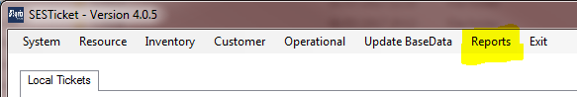

All reports screen has a menu to print, export, etc.



1 – Print Button

2 – Export Option: With this option you can export to Excel, Word, PDF and Excel.



#### REPORTS AVAILABLE

|  |  |
| --- | --- |
| **Report** | **Description** |
| Ticket Analytical | The report has information about Ticket in Analytical level |
| Ticket Sales Item | The report has information about the Sales made by Tickets, divided by Contract Layout and with Totals (taxes, discounts, etc.) |
| Ticket Equipment | The report has information about the Equipment used by Tickets |
| Ticket Worker | The report has information about the workers who works on each Ticket |
| Inventory Analytical | The report has information about the Inventory Item in Analytical level. |